Group: NEM04 |  |  | Subject: English | Term: 3
Teacher: |  | Liz Lynch-Smith
Curriculum: Secondary One Fundamentals
Term 1 focus:
HT1 - Shakespeare – Twelfth Night
In our Shakespeare half term, we will be reading Twelfth Night. We will use different strategies to help understand and enjoy the play, with a focus on interpretation of ideas and how these ideas were shaped by the historical period and may be understood differently today. We will look closely at how different characters’ language use expresses love at various points, and how gender is played with in the story. As well as reading extracts in class, we will also watch different performances to see how it can be staged and to help the students understand it as a play.
HT2 – Poetry
Our poetry half term to finish the year is always focused principally on enjoyment of poetry and language, with students given equal opportunity to write poems as read them, and experiment with rhythm and figurative language to express themselves in different ways. We will focus on a different style of poem/s each week and then use this as a start point for our own writing.

Reading:
HT5: Understanding the text and using evidence
HT2: Enjoying the text

KO1 | In most reading, a range of strategies used mostly effectively to read with fluency, understanding and expression
KO3 | Across a range of reading, comments make inferences based on evidence from different points in the text, often correct
KO4 | Across a range of reading, some structural choices identified with simple comment; identifies some basic organisational features
KO5 | Across a range of reading, some basic language features identified; simple comments on writer’s choices
KO6 | Across a range of reading, main purpose identified; simple comments show some awareness of writer’s viewpoint and overall effect on reader
KO7 | Across a range of reading, simple comment identifies common features and effect that the reader’s or writer’s context has on the meaning
Writing:
HT1: Effective organisation of ideas and evidence
HT2: Writing poetry

KO1 | Across a range of writing, relevant ideas, some detail; straightforward viewpoint generally established and maintained
KO2 | In most writing, general purpose established; main features sometimes signalled; some appropriate style and attention to reader
KO3 | Across a range of writing, ideas organised simply by clustering related points/ time sequence; sequencing generally logical; some signalling
KO5 | Across a range of writing, some variety, use of connectives, in sentences; some variation, generally accurate, in tense and verb forms sentences
KO7 | Across a range of writing, some evidence of deliberate vocabulary choices; some expansion of general vocabulary to match topic

Tier Three Keywords:
infer | identify | structure | plot | character | scene
playwright | Elizabethan | Iambic pentameter | verse | meter | gender
Elizabethan | metaphor | imagery | stanza

Recommended Reading:

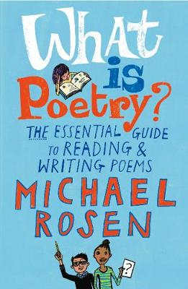
Over many years as a working poet, Michael Rosen has thought a great deal about what poems are, what they can do and the pleasure that comes from writing and reading poetry. In this invaluable handbook, he shares this knowledge and experience in book form for the very first time. Starting with a detailed analysis of a number of classic poems, he offers a real “writer’s guide” to writing and performing poems, as well as a wealth of technical information and tips. He then takes a fascinating look at a selection of his own poems and explains how and why he wrote them.

