AS |  | Biology |  | Term 3  April-July 2025
Teacher : |  |  | Nayna
Biological molecules
1 | The variety of life, both past and present, is extensive, but the biochemical basis of life is similar for all living things.  Monomers (Single unit) are the smaller units from which large polymers ( many units joined together) are formed. The four main ones to consider are: * Carbohydrates, *Proteins, *Lipids (Fats) and *Mineral ions
2 | Carbohydrates:  *Monosaccharides are the monomers from which larger carbohydrates are made. Glucose, galactose and fructose are common monosaccharides.  Glucose has two isomers, α-glucose and β-glucose.  *Structure of the two isomers.  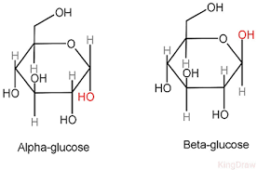  Notice the placement of the OH group determining if its an alpha or a beta molecules
3 | *Condendsation reactions: A condensation reaction joins two molecules together with the formation of a chemical bond and involves the elimination of a molecule of water.  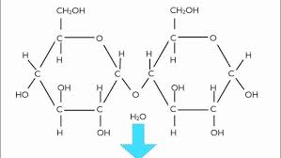  *Hydrolysis Reaction: A hydrolysis reaction breaks a chemical bond between two molecules and involves the use of a water molecule.  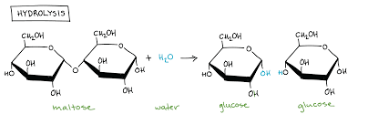  *Diagramatic representation of both and their importance
4 | *A condensation reaction between two monosaccharides forms a glycosidic bond.  *Disaccharides are formed by the condensation of two monosaccharides:  *Maltose is a disaccharide formed by condensation of two glucose molecules  *Sucrose is a disaccharide formed by condensation of a glucose molecule and a fructose molecule  *Lactose is a disaccharide formed by condensation of a glucose molecule and a galactose molecule  Tests for glucose/sugars/ reducing sugars.  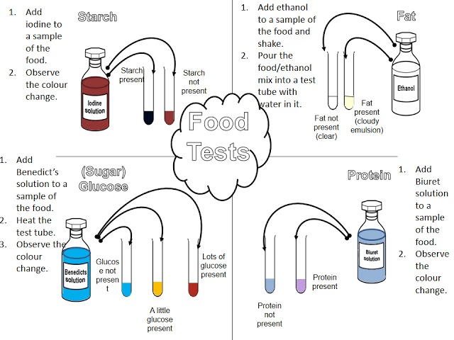
5 | Lipids: Triglycerides and phospholipids are two groups of lipid.  Triglycerides are formed by the condensation of one molecule of glycerol and three molecules of fatty acid. Diagramatic reprentation.  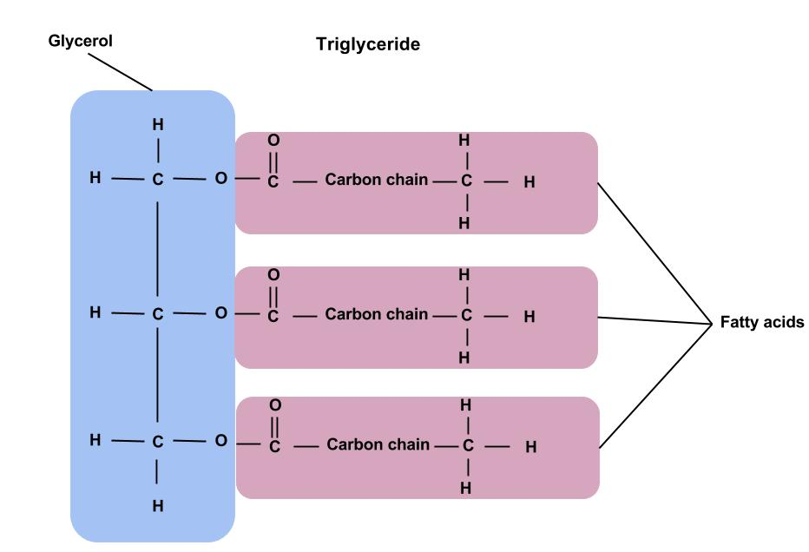  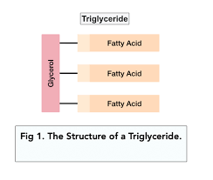
6 | A condensation reaction between glycerol and a fatty acid (RCOOH) forms an ester bond.  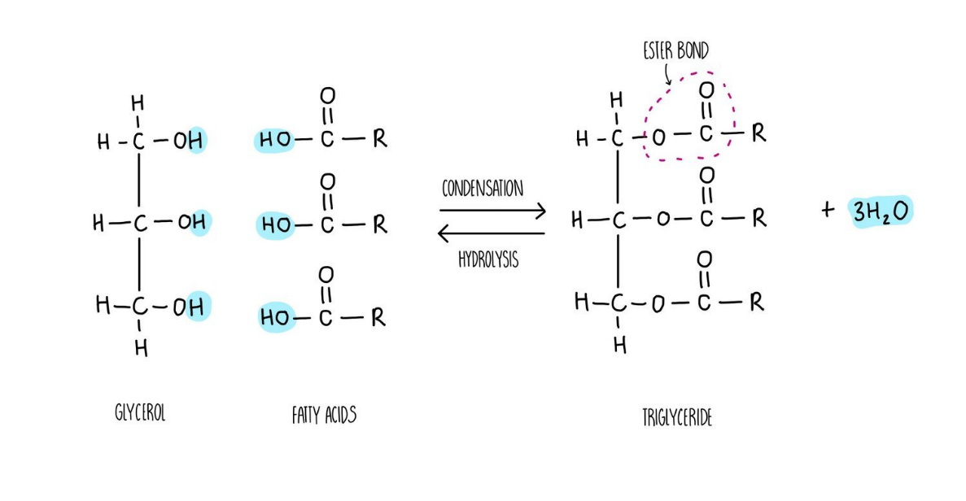  The R-group of a fatty acid may be saturated or unsaturated.  In phospholipids, one of the fatty acids of a triglyceride is substituted by a phosphate-containing group.  Recognise, from diagrams, saturated and unsaturated fatty acids. Explain the different properties of triglycerides and phospholipids  The different properties of triglycerides and phospholipids related to their different structures.  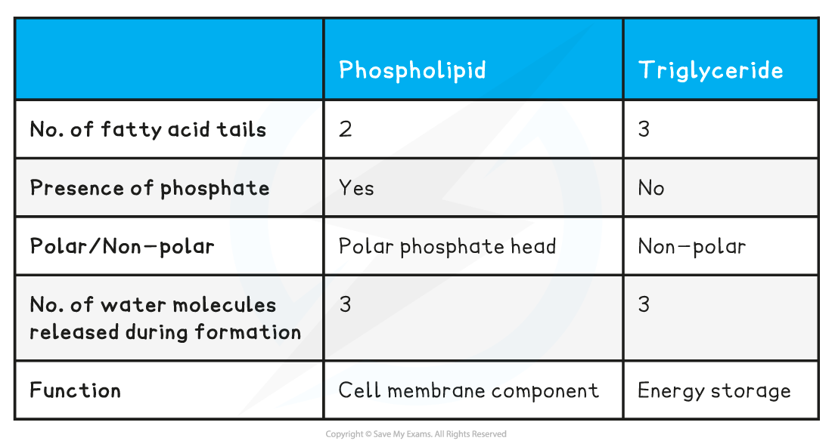  The emulsion test for lipids.  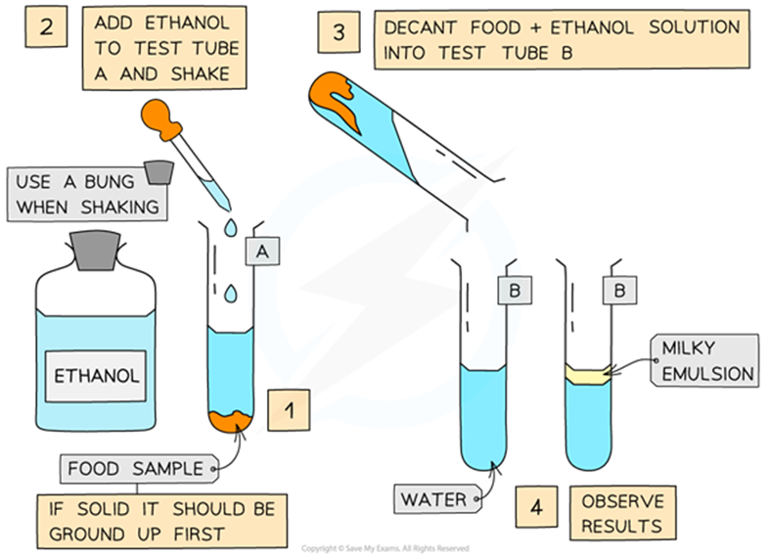
7 | Differences between phospholipids and triglycerides  - Phospholipids and triglycerides are quite similar. They are both composed of fatty acid chains attached to glycerol. The main difference is that one of the three hydrophobic fatty acid tails is replaced by a hydrophilic phosphate group in phospholipids.  - Phospholipids have a hydrophilic region as well as a hydrophobic region (while triglycerides are entirely hydrophobic), and because of this, phospholipids form micelles or bilayers when in solution, which is something that triglycerides do not do.  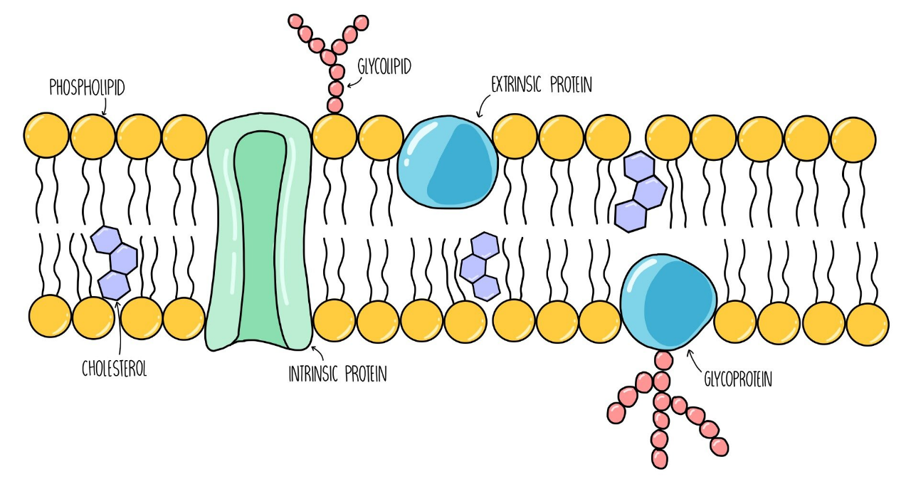  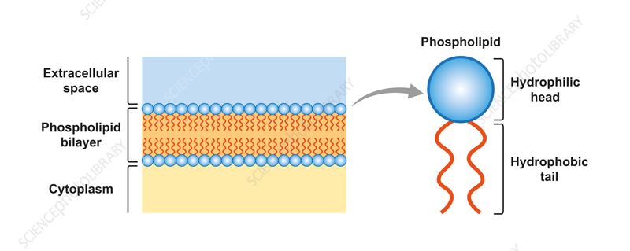
8 | Proteins: Amino acids are the monomers from which proteins are made and contain the element nitrogen  The general structure of an amino acid.  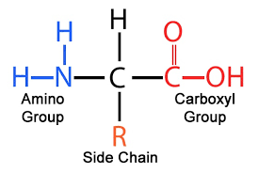  The NH2 represents an amine group, COOH represents a carboxyl group and R represents a side chain. The twenty amino acids that are common in all organisms differ only in their side group.
9 | *A condensation reaction between two amino acids forms a peptide bond.  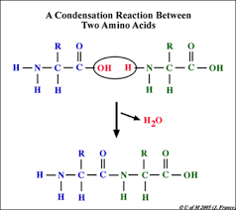  *Polypeptides are formed by the condensation of many amino acids. Each type of protein has a unique sequence of amino acids, exactly the same from one molecule to the next.  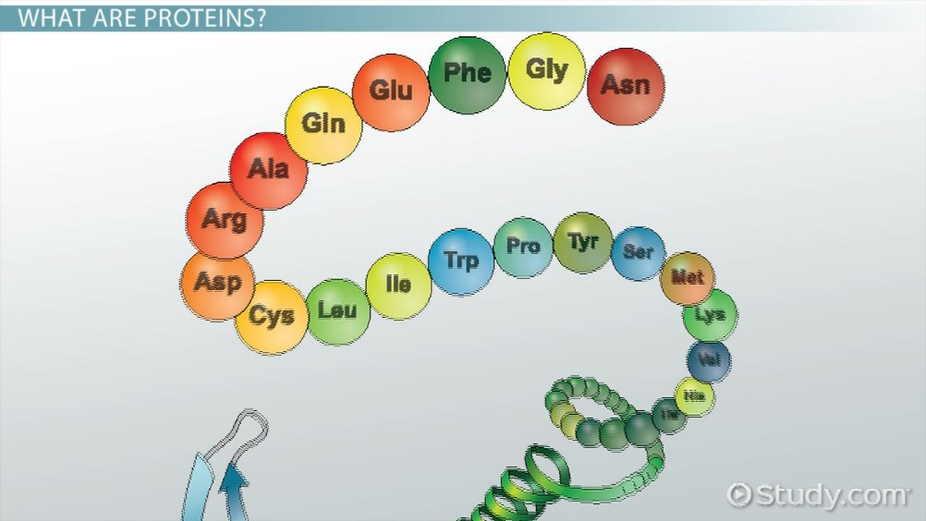  A functional protein may contain one or more polypeptides.  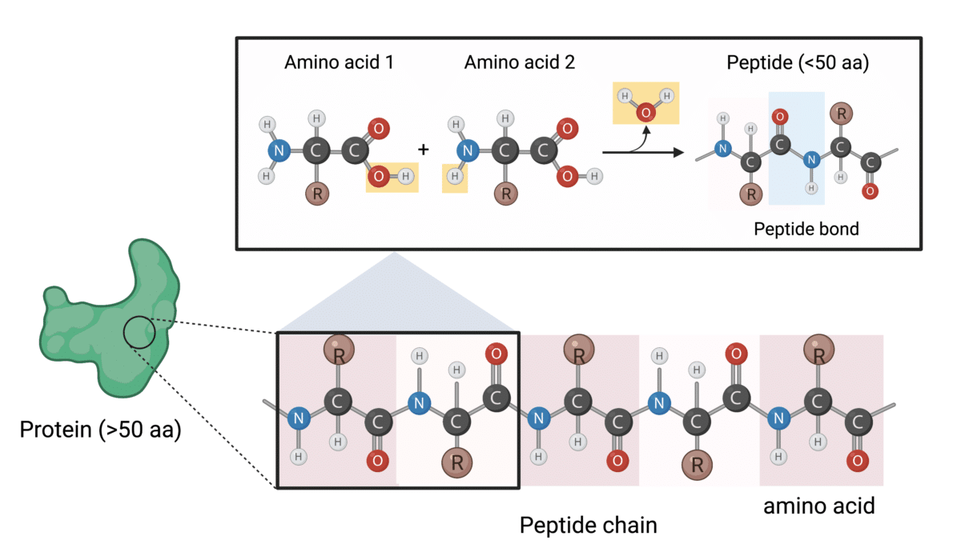  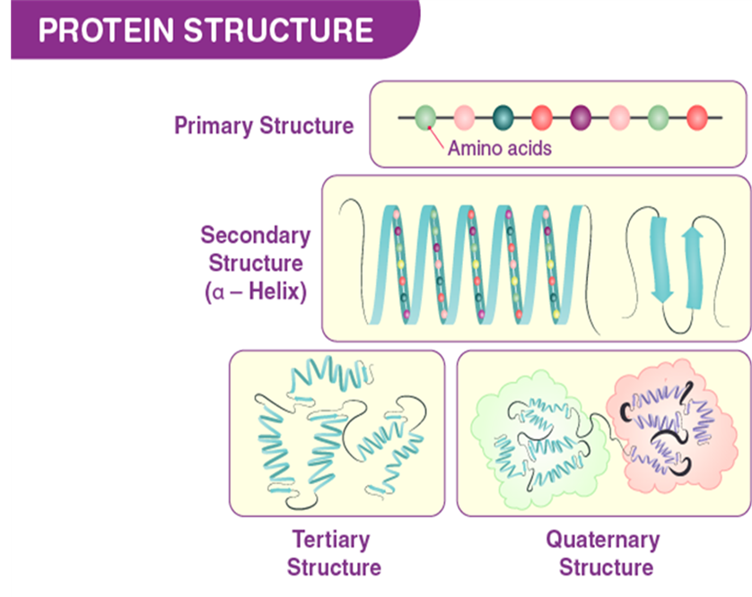
10 | The role of hydrogen bonds, ionic bonds and disulfide bridges in the structure of proteins.  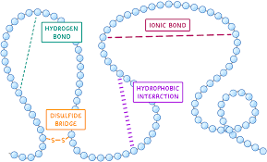
11 | - Hydrogen Bonds: Hydrogen bonding between amino groups and carboxyl groups in neighboring regions of the protein chain sometimes causes certain patterns of folding to occur. Known as alpha helices and beta sheets, these stable folding patterns make up the secondary structure of a protein. Hydrogen bonds hold the two strands of DNA helix together, and in proteins they hold α-helices and β-sheets together.  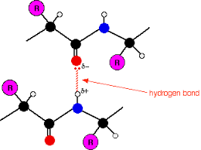  - Ionic Bonds: Ionic bonds are formed as atoms of amino acids bearing opposite electrical charges are juxtaposed. Ionic bonds can be important to protein structure because they are potent electrostatic attractions. In the hydrophobic interior of proteins, ionic bonds can even approach the strength of covalent bonds.  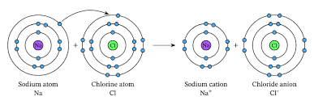  - Disulphide Bridge: Disulfide bonds have classically been shown to stabilize proteins by maintaining overall structure via intermolecular and intra-domain covalent bonds between two cysteine residues  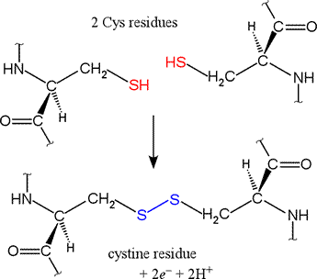  - Hydrophobic Interactions :The energetics of hydrophobic bond formation drives amino acids with hydrophobic side chains into the interior of the protein, in most cases; this is a very important component of proper protein folding.  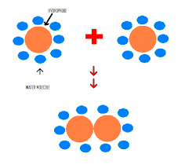  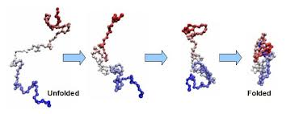
12 | Proteins have a variety of functions within all living organisms. The relationship between structure and function:  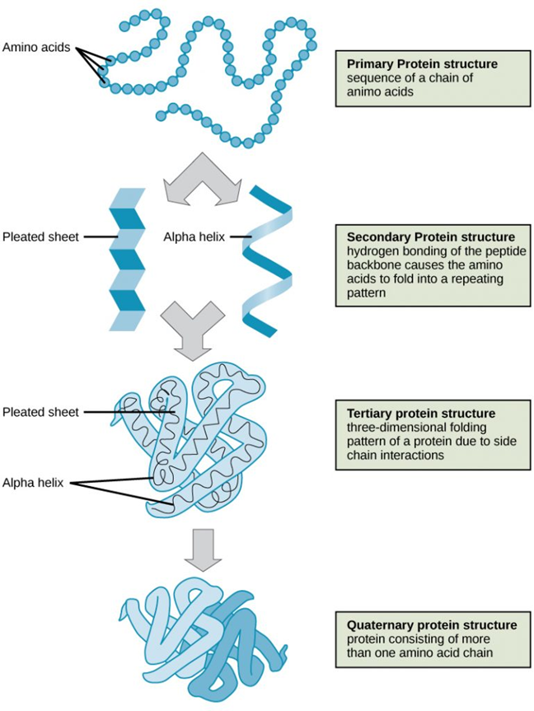  - Primary: The primary structure of a protein is defined as the sequence of amino acids linked together to form a polypeptide chain. Each amino acid is linked to the next amino acid through peptide bonds  - Secondary: The most common types of secondary structures are the α helix and the β pleated sheet. Both structures are held in shape by hydrogen bonds, which form between the carboxyl O of one amino acid and the amino H of another.  - Tertiary: The tertiary structure of a protein refers to the overall three-dimensional arrangement of its polypeptide chain in space. It is generally stabilized by outside polar hydrophilic hydrogen and ionic bond interactions, and internal hydrophobic interactions between nonpolar amino acid side chains.  - Quaternary structure: The quaternary structure exists in proteins consisting of two or more identical or different polypeptide chains (subunits). These proteins are called oligomers because they have two or more subunits. The quaternary structure describes the manner in which subunits are arranged in the native protein.
13 | The biuret test for proteins.  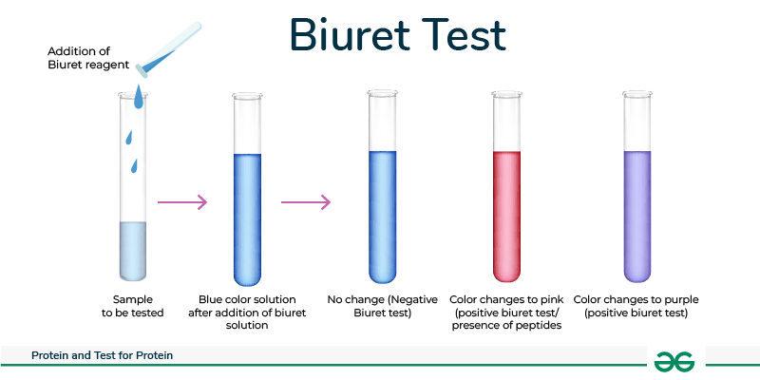
 | Enzymes are proteins
14 | *Each enzyme lowers the activation energy of the reaction it catalyses.  *The induced-fit model of enzyme action.  *The properties of an enzyme relate to the tertiary structure of its active site and its ability to combine with complementary substrate(s) to form an enzyme-substrate complex.
15 | The specificity of enzymes  *The effects of the following factors on the rate of enzyme-controlled reactions –  Enzyme concentration,  Substrate concentration,  Soncentration of competitive and of non-competitive inhibitors,  pH and  Temperature.  Students should be able to:  appreciate how models of enzyme action have changed over time  appreciate that enzymes catalyse a wide range of intracellular and extracellular reactions that determine structures and functions from cellular to whole-organism level
16 | Required practical 1 : Investigation into the effect of a named variable on the rate of an enzyme-controlled reaction.
17 | Water is a major component of cells. It has several properties that are important in biology.  In particular, water:  *is a metabolite in many metabolic reactions, including condensation and hydrolysis reactions  *is an important solvent in which metabolic reactions occur  *has a relatively high heat capacity, buffering changes in temperature  *has a relatively large latent heat of vaporisation, providing a cooling effect with little loss of water through evaporation  *has strong cohesion between water molecules; this supports columns of water in the tube-like transport cells of plants and produces surface tension where water meets air.
18 | Inorganic ions occur in solution in the cytoplasm and body fluids of organisms, some in high concentrations and others in very low concentrations.  *Each type of ion has a specific role, depending on its properties.  *Students should be able to recognise the role of ions in the following topics: hydrogen ions and pH; iron ions as a component of haemoglobin; sodium ions in the co-transport of glucose and amino acids; and phosphate ions as components of DNA and of ATP.
19 | ASSESSMENT:  Through recall and responding to past exam questions as well as supportive questions which test knowledge and understanding.

