Group: BR01 |  |  | Subject: Computing |  | Term: 3  14/04/25 – 18/07/25
Teacher: |  | Enike
Curriculum: Computer Science GCSE
Term 3 focus:
Introduction to Cyber Security:
This module introduces students to the fundamentals of cyber security, helping them understand the importance of protecting data, systems, and networks in an increasingly digital world. It aims to build awareness of potential online threats and the skills needed to safeguard against them.

Python programming:
This module allows students to bring code to life by applying their programming knowledge to control physical devices such as microcontrollers and sensors. It blends coding with hands-on interaction, helping students understand how software interacts with hardware in real-world systems.
 | Objective |  |  | Attendance |  | How do you feel about it [end of lesson]
1 | I can explain how human error poses security risks to data |  |  | Where you around when this was taught? |  | G = Good  B = Bad  N = Need more support
2 | I can define what hacking means in the context of cyber security
3 | I can define a DDos attack
4 | I can identify strategies of how to reduce brute force attacks
5 | I can recall the different types of Malware that affect computers
6 | I can explain how malicious bots can have an impact on social issues
7 | I can compare how security threats can impact organisations
8 | I can identify effective methods to prevent cyberattacks
9 | I can describe what a Microbit is and how it works
10 | I can write a program that uses a Microbits built in inputs and outputs
11 | I can write a program that can write a program that can communicate with other devices through radio
12 | I can implement a physical computing project while following a project plan

Tier Three Keywords:
Malware | Phishing | Spyware | Ransomware | Adware | Data Protection
DDoS | Networks | Cyber attack | Micro:bit | Project plan | Input and Output Devices
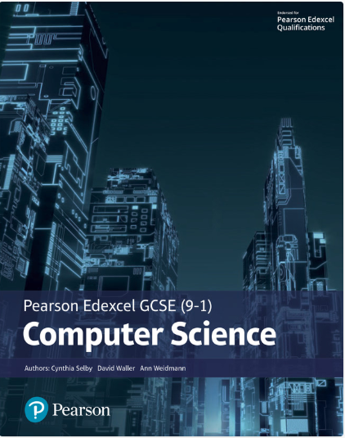
The Pearson Edexcel GCSE (9-1) Computer Science 2020 student book offers:
- plenty of practical activities for programming that follow the PRIMM pedagogy
- real world examples and case studies of Computer Science in Action to help make the content relevant and inspiring to students
- worked examples and activities using the PLS or ‘Programming Language Subset’ (Python) for a simple and comprehensive approach to programming
- simplified content to make it as accessible as possible.
This Student Book also helps students concise and productive exam preparation.
Recommended Reading

Assessment

Formative | Summative
Formative assessments will be done throughout the Computing lessons.  The start of the lesson will have DNA set out for memory recall. There will be questioning during modelling, encouraging students to explain and justify their working as well as checking work.  There will also be exit tickets used at intervals during the course of study for each module. | Students will be given assessments for each module that will be a summary of what they have been learning. Through these assessments students will be able to showcase their knowledge and how much they are retaining in their long-term memory  This will inform further term planning where lessons are concerned and expose any misconceptions and misunderstandings.

