Group: EW08 |  |  | Subject: Computing |  | Term: 3  14/04/25 – 18/07/25
Teacher: |  | Enike
Curriculum: Computer Science GCSE
Term 3 focus:
E – Safety
This module introduces students to the key concepts and practices of staying safe online. It aims to build awareness of digital risks, promote responsible online behaviour, and develop strategies for handling online issues.

Introduction to Scratch
This beginner-friendly module introduces students to the fundamentals of programming using Scratch, a visual programming language. Through creative projects, students develop core computational thinking skills and gain confidence in coding
 | Objective |  |  | Attendance |  | How do you feel about it [end of lesson]
1 | I can explain what self-image is and what having an online identity is |  |  | Where you in attendance when this was taught? |  | G = Good  B = Bad  N = Need more support
2 | I can explain how to relate with people online and to set boundaries to protect myself online
3 | I know what an online reputation is and I understand what builds an online reputation
4 | I can define online bullying and I know what to do if I or someone I know is experiencing online bullying
5 | I can define the different types of online bullying
6 | I know what Fake news is and how to spot Fake news online
7 | I know how to ensure I use the privacy features on all my social accounts to protect myself online
8 | I can identify different objects in Scratch
9 | I can identify Sprites and how they are used in scratch
10 | I can design a scratch program that follows a specific set of instruction
11 | I can program a sequence of connected commands in scratch
12 | I can use sound and commands in one project
13 | I can create a simple game in scratch

Tier Three Keywords:
Online Safety | Reputation | Cyber bullying | Privacy | Fake news | Social Media
Scratch | Programming | Sequence | Coding | Command | Sprite
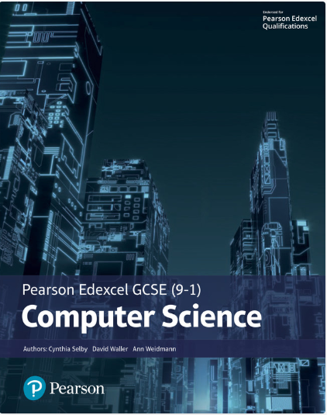The Pearson Edexcel GCSE (9-1) Computer Science 2020 student book offers:
- plenty of practical activities for programming that follow the PRIMM pedagogy
- real world examples and case studies of Computer Science in Action to help make the content relevant and inspiring to students
- worked examples and activities using the PLS or ‘Programming Language Subset’ (Python) for a simple and comprehensive approach to programming
- simplified content to make it as accessible as possible.
This Student Book also helps students concise and productive exam preparation.
Recommended Reading

Assessment

Formative | Summative
Formative assessments will be done throughout the Computing lessons.  The start of the lesson will have DNA set out for memory recall. There will be questioning during modelling, encouraging students to explain and justify their working as well as checking work.  There will also be exit tickets used at intervals during the course of study for each module. | Students will be given assessments for each module that will be a summary of what they have been learning. Through these assessments students will be able to showcase their knowledge and how much they are retaining in their long-term memory  This will inform further term planning where lessons are concerned and expose any misconceptions and misunderstandings.

