Group: NEC06 |  |  | Subject: Computing |  | Term: 3  14/04/25 – 18/07/25
Teacher: |  | Enike
Curriculum: Computer Science GCSE
Term 3 focus:

Robotics
This module introduces students to the basics of robotics and physical computing using BBC micro: bits. It focuses on building, programming, and controlling simple robots, developing key computational thinking and design skills

Data representation
This module introduces students to how computers represent different types of data using binary. It covers the basic principles behind numbers, text, images, and sound in computing, helping students understand how digital devices store and process information
 | Objective |  |  | Attendance |  | How do you feel about it [end of lesson]
1 | I can recall the different components of a microbit |  |  | Where you around when this was taught |  | G = Good  B = Bad  N = Need more support
2 | I can programme a microbit to move forward and backwards
3 | I can programme a microbit to complete a full slow turn to the left and again to the right
4 | I can programme a microbit to make sound and play a tune
5 | I can programme a microbit to play two games
6 | I can make a creative programme for a microbit to accomplish a specific task
7 | I can recall what data representation is
8 | I know what a bit is
9 | I know what binary is
10 | I understand binary place values are and I can convert binary to denary and vice versa

Tier Three Keywords:
microbit | programme | component | motors | movement | sound
Binary | Place values | Bit | Byte | Nibble | Denary
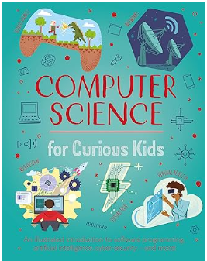Covering Artificial Intelligence, coding, virtual reality and more, this entertaining guide explores the history of computing developments and its role in society today. Students can discover how computing is used in space exploration, how microprocessors work, the famous figures who revolutionised our world and other eye-opening facts. These new concepts pop off the page, thanks to vibrant diagrams and an engaging, energetic prose style.
Recommended Reading

Assessment
Formative | Summative
Formative assessments will be done throughout the Computing lessons.  The start of the lesson will have DNA set out for memory recall. There will be questioning during modelling, encouraging students to explain and justify their working as well as checking work.  There will also be exit tickets used at intervals during the course of study for each module. | Students will be given assessments for each module that will be a summary of what they have been learning. Through these assessments students will be able to showcase their knowledge and how much they are retaining in their long-term memory  This will inform further term planning where lessons are concerned and expose any misconceptions and misunderstandings.

