S2 Exploring CD - BTEC |  |  | Subject: Computing |  | Term: 3  14/04/25 – 18/07/25
Teacher: |  | Enike
Curriculum: BTEC Information and Creative Technology

Unit 3: Learning Aim A
Complete the written section of the design stage of unit 3 which focuses on showing students how to plan for a project.
Students will focus on learning how to create time lines, Asset tables, Structure charts and detailed story boards

Unit 6: Learning Aim A
Students will be taking their time to Understand the applications and features of digital graphic products
The unit is all about creating digital graphics. Students will need to Investigate Two Different Graphic Products. The two graphic products should be designed for different purposes, for example; logos, signs, posters, magazine covers, packaging, web graphics, engineering drawings, manuals, imagery in movies or computer games

Term 3 focus:

 | Outcome |  |  | Attendance |  | How do you feel about it [end of lesson]
 |  |  |  | Where you present when it was taught? |  | G = Good  B = Bad  N = Need more support
1 | I can write a description of the aim and purpose of a given Scenario
2 | I can produce a project timeline based on a given scenario
3 | I can create a detailed structure chart to indicate navigation for my portfolio web page
4 | I can create a table of ready-made assets with relevant references for my portfolio
5 | I am able to create alternative design solutions for my portfolio
6 | I am able to write a design justification for a product
7 | I can explain the intended purpose of a graphics product
8 | I understand how to identify the main features of graphics products
9 | I can analyse a graphics product and check if it is fit for purpose based on a specification
10 | I can discuss the strengths and weaknesses of a graphics product

Tier Three Keywords:
Timeline | Structure Chart | Asset table | Story Board | Graphics | Texture
Resolution | Products
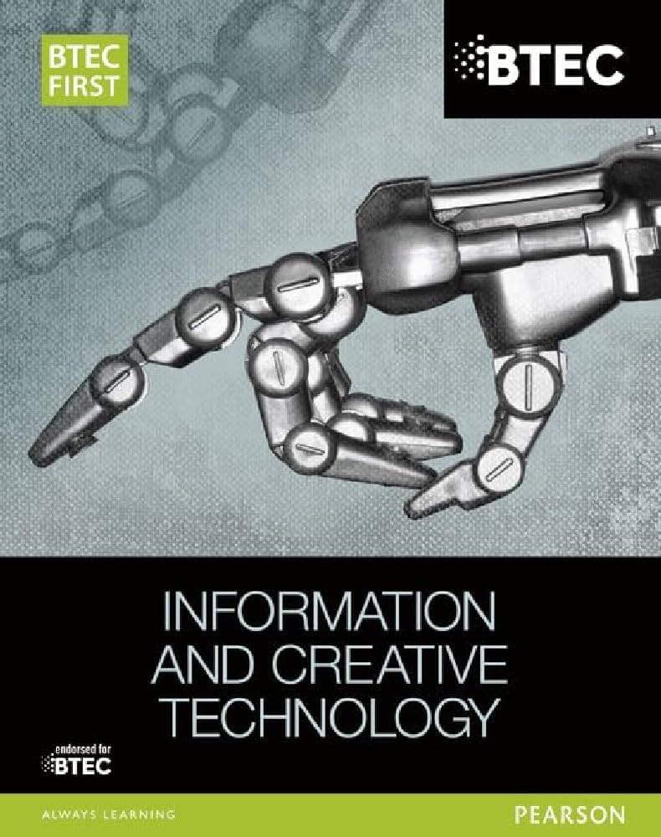
This is the BTEC FIRST book that is related to this module and students would get a lot of useful information from this book that would prepare them for the BTEC Qualification
Recommended Reading:
Assessment
Formative | Summative
Formative assessments will be done throughout the Computing lessons.  The start of the lesson will have DNA set out for memory recall. There will be questioning during modelling, encouraging students to explain and justify their working as well as checking work.  There will also be exit tickets used at intervals during the course of study for each module. | Students will be given assessments for each module with in internally verified assignment. Assignments will have hand in and hand out dates with assignment specifications. These will be marked internally  This will inform further term planning where lessons are concerned and expose any misconceptions and misunderstandings.

