Group:  S2 Exploring M5 |  |  | Subject:  Horticulture | Term: 3
Teacher: |  | Ally Simpson
Curriculum: Pearson BTEC Level1 Introductory in Land-Based Studies.
Term 3: Focus – to revisit work covered on Terms 1 & 2 while doing RHS Level 1, explain the change in the course and link the two together.
1 | To review work completed in Terms 1 & 2, including Health & Safety, risks and hazards of practical tasks and use of tools.
2 | To understand the difference between planting bulbs and seeds.
3 | To review tools and equipment for a variety of activities including carrying out propagation.
4 | To discuss where seeds come from and examples of seeds we have collected as well as ones we have bought.
5 | To review cuttings and growing tips.
6 | To discuss conditions for growth of seeds; temperature, moisture, light, oxygen, growing media.
7 | To watch a clip of ‘The Private Life of Plants’ to understand why plants survive.
8 | To demonstrate soil consolidation, levelling and tilth production for (a) seeding, broadcast or in drills & (b) planting.
9 | To carry out any necessary preparation of the planting medium according to instructions.
10
Tier Three Keywords:
propagation | temperature | oxygen
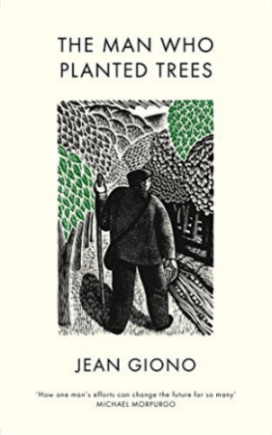
Recommended Reading:

