Group: Y11/Y12  Animal Care |  |  | Subject: Community and Outdoor Education | Term: 3
Teacher: |  | Abbie Jotham/ Kyle Hall
Curriculum: Animal Care Level 2
Term 3 focus: Completing Animal Handling component and assessment. Start looking at the Animal accommodation and how to prepare it and keep it safe.
Health Checks on small animals.
Students will continue to develop their confidence in handling and caring for the WHF small animals and demonstrate their understanding in independent activities working towards the Level 2 qualification.

1 | Know the suitability of accommodation for different animals including invertebrates birds and mammals
2 | Know the different features of animal enclosures
3 | Know the five welfare needs of animals
4 | Prepare animal housing and check space, cleanliness and ventilation.
5 | Prepare and check fixtures and fittings and equipment within animal housing.
6 | Prepare and check animal bedding and list the purposes.
7 | Demonstrate how to carry out a routine health check
8 | Describe and record the signs of good health in different animals
9 | Describe and record the signs of ill health in different animals
Tier Three Keywords:
disease | welfare | pathogen | feature | environment | design
behaviour | PPE | ventilation | hazard | legislation
Recommended Reading:
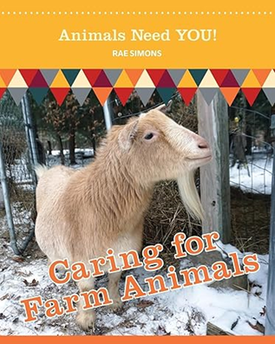

Assessment
Btec level 1/ 2 handling Animals component 1 assessment

