Group: S2 Exploring |  | Subject: Perf Arts | Term: 3
Teacher: | Natalie Wood Steph Kirton
Curriculum: BTEC Assignment Unit 3 Acting skills (Feb-Jul)

Term 3 focus:
The assignment brief for Unit 3 Acting Skills, incorporating the teaching and learning from term 1 and the first half of term two to work towards a final performance for an audience.

In this term Students will perform their finished piece of work for Unit 3 and submit all evaluation and log book evidence to support this performance.

 | Objective | Attendance | How I felt about it | How I felt about it
1 | Demonstrate use and control of acting skills in practice and development.
2 | Identify strengths and areas to develop in own technique.
3 | Demonstrate acting and personal management skills in rehearsal.
4 | Participate in a performance using technical acting skills.

Tier Three Keywords:
Vocal colour | Phrasing | Spatial awareness | Practitioner | Articulation | Projection
Character | Coordination | Interpretation | Technique

Assessment:
Daily Assessment | Substantive Assessment
Type:  Formative assessment happens throughout Perf Arts lessons, questioning, class discussions and reflections both verbally and in student log books. Students are encouraged to reflect on their practical work and others. | Type:  During summative sharing lessons students will monitored against the termly objectives and will be able to measure their final outcome against the weekly progress and intentions they have been working towards and logging in their books.  Students are not expected to master techniques during this phase but will continue to explore and develop techniques throughout the qualification. Formative and summative assessments will help to set personal targets for their continued development.

Recommended Reading:
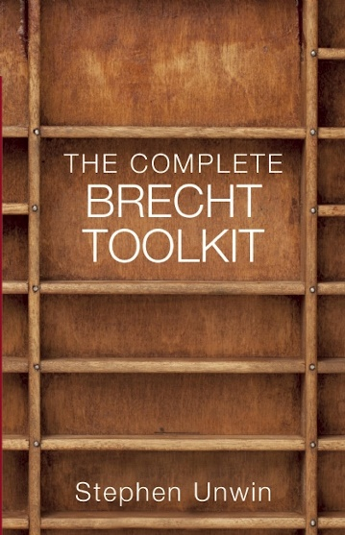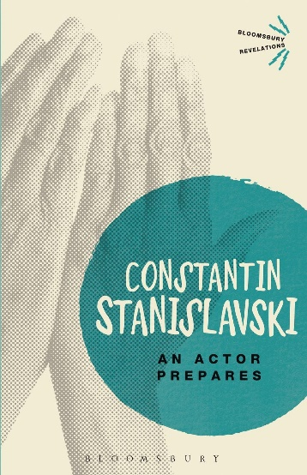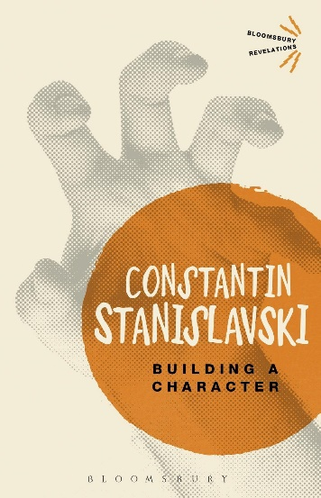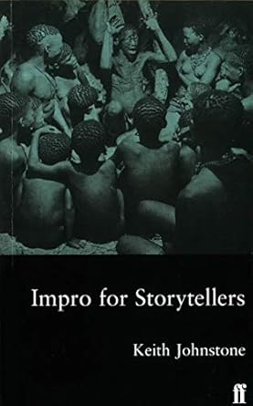

Further resources:
National Theatre resources - https://www.nationaltheatre.org.uk/learn-explore/schools/teacher-resources/?all=true

BBC Bitesize Drama - https://www.bbc.co.uk/bitesize/articles/zd4np4j#zq8yf82

V&A Theatre and Performance archives - https://www.vam.ac.uk/collections/theatre-performance?srsltid=AfmBOoomHjnChVJn9y5bfBwTctyOREHqWD4UNiQMs56ObSdH-KkQSKd-

