Group: EW05 |  |  | Subject: PSHE | Term: 3
Teacher: |  | Rebecca Scott
Curriculum: Study programmes 1,2,3 (KS5)
Term 2 focus: Financial Choices
This term, students will explore key aspects of financial literacy to prepare them for real-life money management. They will learn how to plan and adapt budgets for changing circumstances, such as moving out or starting university, and develop a clear understanding of salary deductions including tax, national insurance, and pensions. Students will evaluate different saving methods, understand their consumer rights, and how to access support when needed. The term will also cover managing financial contracts (such as mobile phone agreements and tenancy), and recognising trustworthy sources of financial advice. Finally, students will assess the risks and benefits of debt arrangements and financial ventures, including identifying and avoiding illegal financial schemes.

1 | L13 how to plan expenditure and budget for changes in circumstances (e.g. when moving out or going to university)
2 | L14 to understand and mange salary deductions including taxation, national insurance, and pensions
3 | L15 to evaluate savings options
4 | L16 to exercise consumer rights, including resolving disputes and accessing appropriate support
5 | L17 to manage financial contracts including mobile phone services and renting items and accommodation; how to identify appropriate advice
6 | L18 to evaluate the potential gains and risks of different debt arrangements and repayment implications
7 | L19 to evaluate the risks in different financial ventures including illegal schemes, e.g. illegal money transfers

Tier Three Keywords:
Consumer | Economy | Budget | Salary | Deduction | Expenditure
Taxations | Pensions | Debt | National insurance | Income tax
Recommended Reading:

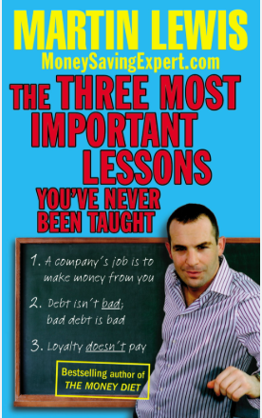
This book is a survival guide to living in one of the world's most competitive consumer economies. We need to change the way we think about money. This book will start you on the path to beating the system, grabbing the best deals and avoiding being ripped off... and it only takes an hour to read.
Consumer campaigner and top TV expert, Martin Lewis, first designed these lessons for a unique TV challenge where he had just one day to turn twelve normal 15-year-olds into Money Saving Experts. Yet this isn't child's play - after the class they went home and saved their parents over £5,000. Now it's time for everyone to learn these golden rules...

