Group: EW07 |  |  | Subject: PSHE | Term: 3
Teacher: |  | Molly Meyrick
Curriculum: Programme of Study 1, 2, 3
Term 3 focus: Financial Choices
To equip students with the knowledge, skills, and confidence to make informed, responsible financial decisions in their personal and professional lives, and to develop financial independence as they transition into adulthood.
1 | Identify different sources of income available to young adults, including employment, student finance, and passive income.
2 | Construct a realistic personal budget, reflecting income, expenses, and savings.
3 | Differentiate between essential needs and lifestyle wants, and understand the implications of prioritising each.
4 | Understand types of borrowing (e.g., credit cards, overdrafts, payday loans) and the associated risks and responsibilities.
5 | Compare financial products, including savings accounts, interest rates, and investment options
6 | Explain how credit scores work, and recognise behaviors that improve or damage them.
7 | Assess the consequences of short- and long-term financial decisions on lifestyle and wellbeing.
8 | Develop a personal financial goal and a strategy to achieve it.

Tier Three Keywords:
Income | Budget | Interest | Overdraft | Financial Planning
Expenditure | Credit | Savings | Credit Score

Recommended Reading:

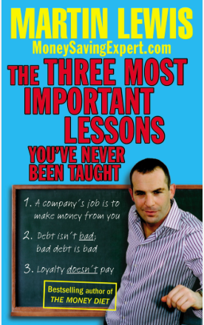
This book is a survival guide to living in one of the world's most competitive consumer economies. We need to change the way we think about money. This book will start you on the path to beating the system, grabbing the best deals and avoiding being ripped off... and it only takes an hour to read.
Consumer campaigner and top TV expert, Martin Lewis, first designed these lessons for a unique TV challenge where he had just one day to turn twelve normal 15-year-olds into Money Saving Experts. Yet this isn't child's play - after the class they went home and saved their parents over £5,000. Now it's time for everyone to learn these golden rules...

