Group: WR05 |  | Subject: Mathematics | Term: 3
Teachers: | Michael Gouldin & Emma Dicksinson
Curriculum: Secondary One Fundamentals
Term 3 focus:
This term we continue to develop our understanding of percentages to find percentages of any amount. We will begin adding and subtracting fractions and also look at how they link with ratios. We will also look at sets of data and begin to read and extract data from charts, tables and graphs. We will also find and use different types of ‘averages’ and apply them alongside the range to sets of numbers.
 | Theme | Objective | Attendance | How I felt about it  
 |  |  | (Date when taught) | End of  lesson | 4 weeks later | End of term
1 | Fractions | I can find percentages of given amounts and find the whole when given a percentage.
2 | Data | I can read and interpret tables charts and graphs
3 | Data | I can find and explain the averages and range of sets of numbers.
4 | Fractions | I can add fractions with the same denominator
5 | Fractions | I can subtract fractions with the same denominator
6 | Fractions | I can explain and apply proportional relationships in different situations ( Ratio)
7
8
9
10

Tier Three Keywords:
mode | mean | median | range | ratio
denominator | numerator | data (set)

Assessment:
Daily Assessment | Substantive Assessment
Type:  Formative assessment happens throughout mathematics lessons, questioning during modelling, encouraging students to explain and justify their working as well as checking work completed. | Type:  During recall lessons objectives will be assessed around 4 weeks after they have been taught in the form of low stakes tasks. Students will have the opportunity to show they are secure in their understanding. Where students are not yet secure, they will be given scaffolding and opportunities to show they are embedding, developing or beginning to use this knowledge.  Students will also attempt problem-solving tasks during recall lessons which give opportunities for them to apply their mathematics to a variety of routine and non-routine problems, giving them an opportunity to show their reasoning and problem-solving skills.

Recommended Reading:

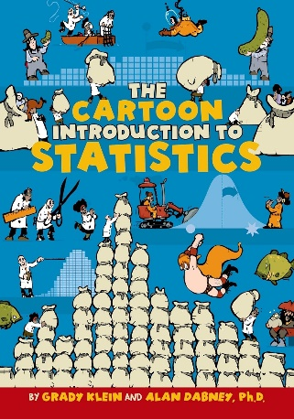
The Cartoon Introduction to Statistics
Author
Grady Klein
Klein and Dabney have created a rollicking narrative about the best ways to make confident statements based on limited information. Timely, authoritative, and a pleasure to read, The Cartoon Introduction to Statistics is an essential guide for students and for curious readers who want to better understand the world around them.

Further resources:
Practice skills:
https://www.mathsgenie.co.uk/
https://www.mathslinks.co.uk/
https://corbettmaths.com/contents/
https://diagnosticquestions.com/

Problem solving:
https://nrich.maths.org/secondary-live-problems-and-recent-solutions
https://www.youcubed.org/tasks/
https://ukmt.org.uk/puzzles
https://www.cut-the-knot.org/
https://www.transum.org/Software/Puzzles/
https://www.mathsisfun.com/puzzles/index.html

