Group: M01 |  |  | Subject: Art and Technologies | Term: 1
Teacher: |  | Natalie W
Curriculum: KC Induction-Secondary Ready
Term 1 focus: Introductory art techniques and 3D sculpture.
Students will explore themes of nature and mark making, building confidence with exploration of art. Students will develop key understanding of the elements of art and how this relates to their own art and the work of other artist. The main themes include the concept of being an alien and how we can all feel alienated in the world and how we can develop a sense of belonging in ourselves and in our wider community.

Food Technology Term 1 Focus: Shaping Breads and Exploring finishes for Bread. Students will develop bread making skills following the health and hygiene standards of the Kitchen students will make a range of bread products.

1 | Use experimentation and creative play to explore a range of mark making techniques using found objects and natural forms
2 | Develop understanding of basic colour theory and how artists use this knowledge to create harmony and contrast in their work
3 | Explore the Seven elements of art using natural forms.
4 | To know about the Surrealist movement and to be able to use creative collage to create a surreal creature
5 | Explore the work of Yinka Shonibare and find out about his ‘Aliens’ series and the importance of his African heritage in his art work.  Develop an understanding the way in which art can be used to express ideas about culture and identity
6 | Produce a 3D sculpture using papier mache construction techniques
7 | Decorate your sculpture using paint, thinking carefully about effective use of pattern and colour
8 | Create a galaxy backdrop for your alien sculpture through experimentation with ink techniques
9 | Record your ideas using your sketchbook and use them to review and revisit and refine ideas
10 | Reflect on your learning and what you have enjoyed through verbal discussion and written evaluation
11 | Share your ideas and experiences with others in school and at home
12 | Work safely in the kitchen, wash hands, apron on.
13 | Make bread dough and shape it, use an oven to cook the bread
14 | Create garlic dough balls, and experiment with different washes, Milk, Egg and Oil. Evaluate and discuss this different finishes to bread.
15 | Design and make your own Mini pizza. Do a taste test.
16 | Wash up and take care of the kitchen and the equipment in the Kitchen.
Tier Three Keywords:
Colour Wheel | Mark making | Value | Pattern | Primary | Secondary
Yinka Shonibare | Papier Mache | Line | Sculpture | Surrealism | Texture
Shape | Form | Negative Space | Baking | Proving | Rising

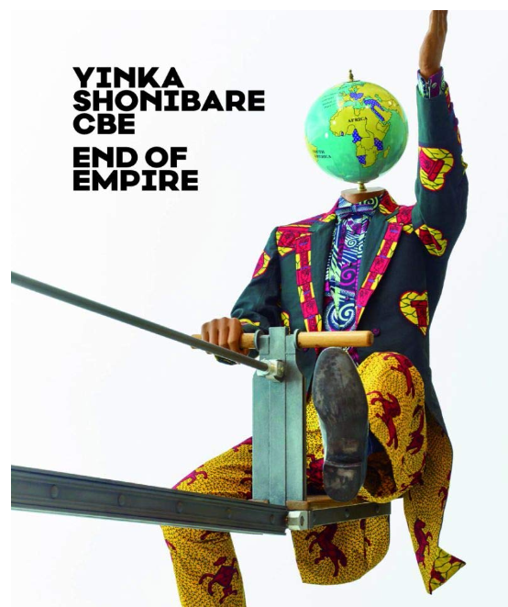
Yinka Shonibare CBE: End of Empire

Since the 1990s, the British-Nigerian artist Yinka Shonibare CBE (*1962, London) has developed opulently executed sculptures and installations, colourful collages and theatrically staged photographs and films. To do so he transforms episodes from art and history whose effects influence our present-day lives. The volume takes up the traces of colonialism and its consequences for role models, worldviews and body images in the works of Shonibare.
Recommended Reading:

Tate: Colour: A Visual History

From Isaac Newton's investigations through to Olafur Eliasson's experiential creations, this stunning book documents the fascinating story of colour with an extraordinary collection of original colour material that includes charts, wheels, artists' palettes, swatches and schemes.


