Group: M03 |  |  | Subject: Arts and Technology | Term: 1
Teacher: |  | Matt Hall
Curriculum: Secondary One Fundamentals
Term 1 focus: Introductory art techniques, Colour Theory, Art and Nature.
Half term one is all about natural forms and taking inspiration from nature and the changing seasons, and we will be developing our observational drawing, composition and painting skills. Our artist inspiration will be Andy Goldsworthy, Richard Long and Georgia O’Keefe. We will explore their work and respond to it, building up our creative sketchbooks in the process. O’Keefe’s flower paintings will be the start point for our main piece this half term, and the students will use viewfinders and photography to study nature in fine detail, developing their ideas through reflection on their own work and creating large scale paintings on wood or canvas.
In half term two we will move into 3-dimensions, with students building towards creating a sculpture of their own heads, using paper and cardboard. To get there we will look at proportions of the face, creating sketches and models for our final piece.

1 | Develop understanding of basic colour theory. Recap colour wheel. Primary, Secondary and tertiary colour. Tonal strips. Colour matching.
2 | Sort and categorise objects and shapes, grouping by colour and form
3 | Develop composition and observational drawing skills. Use objects found in nature, inspired by Richard Long.
4 | Explore the work of Andy Goldsworthy. Create art inspired by Andy Goldsworthy Using found leaves from the garden.
5 | Use a viewfinder to look at nature close up, reflect on the paintings created by Georgia O Keefe, create your own enlarged flower painting.
6 | Self-portrait. Consider the proportions of your face! Sketch out your face.
7 | Produce a 3D of your head. Use cardboard and cut out shapes, use a hot glue gun and scissors safely.
8 | Record your ideas using your sketchbook and use them to review and revisit and refine ideas
9 | Reflect on your learning and what you have enjoyed through verbal discussion and written evaluation
10 | Share your ideas and experiences with others in school and at home
Tier Three Keywords:
Colour Wheel | Mark making | Value | Pattern | Texture | Shape
Annotating | Composition | Form | Line | Proportions | Nature

Recommended Reading:

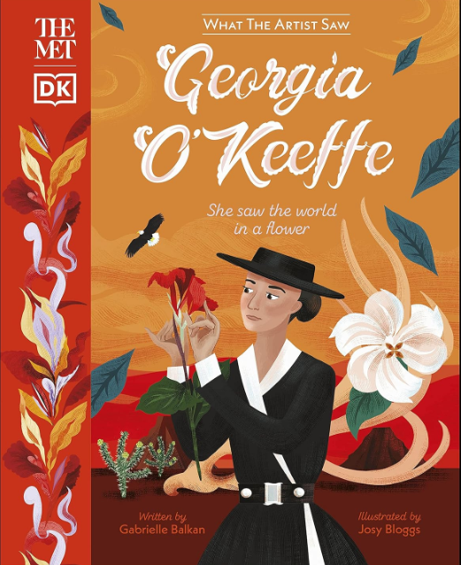

The Met Georgia O'Keeffe

Have you ever wondered exactly what your favourite artists were looking at to make them draw, sculpt, or paint the way they did? In this charming illustrated series of books to keep and collect, created in full collaboration with the Metropolitan Museum of Art, you can see what they saw, and be inspired to create your own artworks, too. In What the Artist Saw: Georgia O'Keeffe, meet famous American painter Georgia O'Keeffe. Step into her life and learn what led her to look closely at nature and paint her iconic paintings of flowers and bones. See the vast New Mexico landscapes that inspired her work. Have a go at producing your own close-up still-life artworks!

