Group: C07 |  |  | Subject: Art | Term: 1
Teacher: |  | Kate Hughes
Curriculum: Art & Design
Term 1 focus:
Natural Forms & Print Making
This term we will be exploring the ways in which Artists and designers are inspired by Natural Forms investigating and responding to the work a variety of historical and contemporary Artists from William Morris to Yayoi Kusama.

We will be taking inspiration from the natural world around us and developing our own natural form representations using a range of artistic media including ink and watercolour. Students will be introduced to a variety of print making techniques including mono printing and lino cut printing and students will be supported to develop their own designs and patterns inspired by natural forms.

1 | I can understand how natural forms can be a source of inspiration in Art and Design
2 | I can experiment with various artistic media, such as pencil, paint, ink and watercolour, to develop natural form representations and create imaginative compositions and patterns inspired by natural forms
3 | I can create simple mono prints inspired by natural forms and from natural materials
4 | I can demonstrate my understanding of Yayoi Kusama’s visual style and creative influences through my own piece of response art
5 | I can create patterns inspired by natural forms using paper cutting techniques inspired by the work of Henry Matisse
6 | I can explore and create different types of patterns, such as brickwork, repeat patterns, rotation, radial symmetry, and mirror symmetry.
7 | I can explain who William Morris is and identify the key features of his art, including his use of natural forms and pattern in design.
8 | I can design my own wallpaper pattern inspired by natural forms and the key artists we’ve studied, including William Morris, Yayoi Kusama, and Henri Matisse.
9 | I understand how to safely create a lino cut print using the appropriate tools
10 | I can create a sampler of my wallpaper or fabric design using polyprint or linocut to replicate my pattern.

Tier Three Keywords:
Print Making | Lino Cut  Print | Mono-print | Visual Style | Repeat Pattern | Sampler
Observational Drawing | Mixed-Media

Recommended Reading:

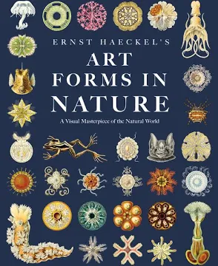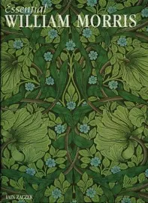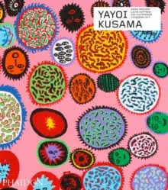
- Ernst Haeckel's Art Forms in Nature: A Visual Masterpiece of the Natural World
- Yayoi Kusama: Revised & expanded edition (Phaidon Contemporary Artists Series)
- Essential William Morris Essential Art, Iain Zaczek & Dr Clair I.R.O'Mahony

