Group: M04 and M05 |  |  | Subject: Creative Arts | Term: 1
Teacher: |  | Beckie
Curriculum: Arts, Media and Music
Term 1 focus: Stop Motion Animation and Classical Music and keyboard introduction.  In term 1 students will develop skills using digital editing software with IPAD/I Movie, stop motion animation technology and apps. Students will plan and design an animation short, develop characters, set design and storyboarding skills. Along the way students reflect and investigate different types of animation and animators. Students begin to investigate the history of film and media and how technology has evolved and transformed the industry. |  |  |  |  | Evaluating my  learning
1 | Understand what a stop-motion film is and how they are created.
2 | Research (using primary and secondary sources) where animation is used in a range of contempory media.
3 | Generate ideas for any characters, backgrounds, storylines
4 | Design and create a character for a stop-motion film using non-hardening modelling clay.
5 | Identify and describe a range (this means more than one) of famous animation artists.
6 | Design and create a set for a stop-motion film using mixed-media.
7 | - Make your models and sets.  - Photograph all stages of pre- production. Reflect on the progress.
8 | Create a storyboard for a stop-motion film.
9 | Use Ipads to shoot and edit your stop-motion film.
10 | - Develop a questionnaire that will allow you to collect information on what the audience thought of your films.
11 | Take part in a showcase of stop-motion films and offer constructive feedback to other students.
Tier

Keywords:
Animation | Modelling | Stop-motion | Storyboard
Form | Review | CGI | Flipbook
Frames | Development | Storyboards | Review

Recommended Reading:

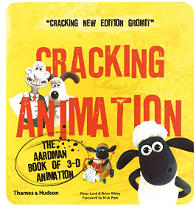Cracking Animation by Peter Lord

Classic Animation, History of Disney. Dancing skeletons, Morph.

