Group: EW08 |  |  | Subject: Arts | Term: 1
Teacher: |  | Rae Salter
Curriculum: Secondary 1 Exploring
Term 1 focus: William Morris/ Musical Theatre trough time

William Morris:
We will explore pattern and the natural world through the works of William Morris. We will explore the life and work of Morris through independent research, experiment creating patterns using natural forms, review and develop our knowledge of printmaking and design and create our own wallpaper pattern using polyprint and/or lino printing.

Musical theatre through time:
From ‘Oklahoma!’ to ‘Hamilton’, we will discuss how musical theatre developed throughout the 20th century to the modern day. We will develop our listening and analysis skills whilst experiencing music from key works of musical theatre and understand the wider context for each work. We will also develop our theory and performance skills by practicing simple melodies from the music we have listened to on the keyboard from standard western musical notation.
1 | Know who William Morris is and what the key features of his artwork are
2 | Explore different types of pattern e.g. brickwork, repeat, rotation, radial symmetry, mirror, half-drop
3 | Create patterns using natural forms in multiple mediums (pencil, paint, print etc.)
4 | Design a wallpaper in the style of William Morris using pattern and natural form
5 | Create a sampler of the wallpaper design using Lino printing or polyprint
6 | Understand how musical theatre has developed since the 1940s
7 | Experience and analyse music from key musicals of each decade from 1940s to 2010s
8 | Know the historical context for key musicals of each decade from 1940s to 2010s and understand how this influenced the musical.
9 | Identify middle C on a Keyboard
10 | Play simple melodies and chord accompaniments on a keyboard from standard notation.
Tier Three Keywords:
Printmaking | Ink | Rotation | Symmetry | Pattern | Radial
Triad | Clef | Chorus | Opera | Musical | Crotchet
Quaver | Minim | Rest
Recommended Reading:
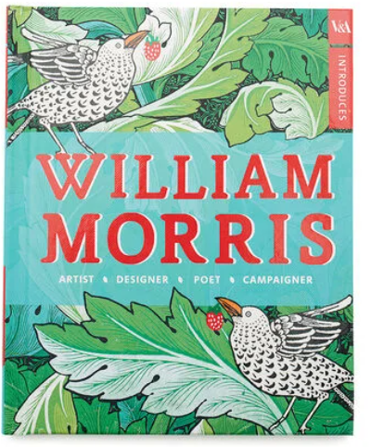
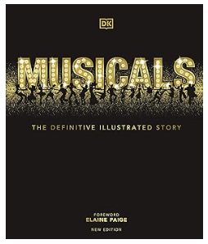
V&A Introduces: William Morris
William Morris believed in 'art for all' and that beauty had the power to transform everyday lives.
An artist, designer, poet and campaigner, William Morris revolutionized British design and his ideas continue to inspire people today.

Musicals: The Definitive Illustrated Story
From The Wizard of Oz and The Sound of Music to Mamma Mia and Les Misérables, fall in love all over again with the songs, stories, characters, creators, and legendary stars from every era of musical theatre.
Take a journey through the years and immerse yourself in the behind-the-scenes world of musical theatre! From the dance halls and vaudeville to the silver screen and sensational Broadway shows, this go-to musical guide has all the glitter and glamour of the West End.

