Alongside our amazing suite of books and reading materials onsite at Kenwood Academy, there are also a number of amazing websites and apps which have a wide range of online reading materials all for free! These range from e-books, audio books, publications and more. Explore the websites below to be transported into an online world of reading…

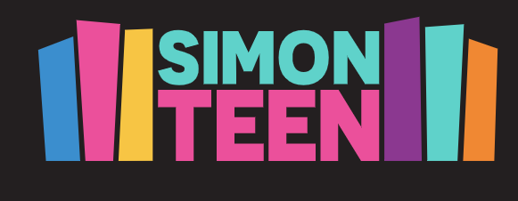 https://simonteen.com/free-reads/
Riveted by Simon Teen is an online community for anyone that loves young adult fiction! You can read young adult books for FREE, discover your new favourite books and authors, enter for the chance to win new and upcoming releases, and more!

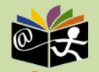 http://www.childrenslibrary.org/index.html
The mission of the International Children's Digital Library Foundation (ICDL Foundation) is to support the world's children in becoming effective members of the global community - who exhibit tolerance and respect for diverse cultures, languages and ideas by making the best in children's literature available online free of charge. The Foundation pursues its vision by building a digital library of outstanding children's books from around the world and supporting communities of children and adults in exploring and using this literature through innovative technology.

https://www.barnesandnoble.com/b/free-ebooks/ebooks-nook/teens-ya/teen-fiction/_/N-ry0Z8qaZ19zn;jsessionid=63A4486D5390A2FFF497D9D7955480ED.prodny_store02-atgap04
Barnes & Noble have hundreds of free teen e-books available to download to your device or read online!

 https://www.planetebook.com/
Planet eBook is the home of free classic literature! The latest version of the site, with its mobile-friendly design and multi-format eBooks, attempts to make their collection of eBooks available on all devices.

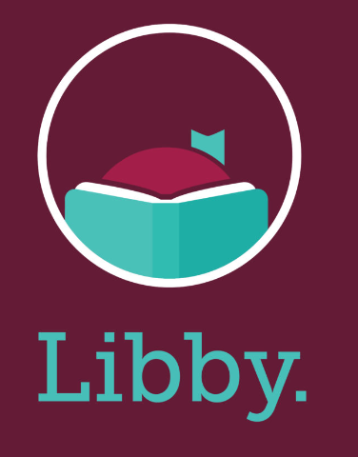https://help.libbyapp.com/en-us/6103.htm
Libby is a free app where you can enjoy ebooks, digital audiobooks, and magazines from your public library. You can stream titles with Wi-Fi or mobile data, or download them for offline use and read anytime, anywhere. All you need to get started is a library card.
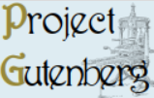 https://www.gutenberg.org/
Project Gutenberg is a library of over 70,000 free eBooks. Choose among free Kindle eBooks, download them or read them online. You will find some of the world’s great literature here.

