Group: EW02 |  |  | Subject: English | Term: 1 | Step: 5
Teacher: |  | Alex Bird and Angus Spencer
Curriculum: Secondary Two Exploring
Term 1 focus:
HT1 - Novel – Lord of the Flies
HT2 - Fact and Fiction in Context

Our first half term focuses on reading skills, and as a class we will be reading Lord of the Flies by William Golding. We start the year this way to help bring the group together in sharing a complete work of literature, and to foster a love of reading. Throughout the half term we will be developing skills of information retrieval, inference and analysis of language and structure, and students will demonstrate these skills through discussion and written responses. Students will be provided with several opportunities in the half term to write longer answers to the question of how Golding uses language to present character.

The writing focus for half term two is transactional writing, using varied non-fiction and fiction extracts as a basis for this. Students will read and emulate different text types – article, review, letter. Our reading focus is all about developing our understanding of context – for example how do the time it was written and the views of the author affect the writing.

Reading:
HT1: Understanding the text and using evidence
HT2: Situating the text in culture

KO2 | I can identify most relevant points from various places. I support my comments and ideas with generally relevant textual references or quotations.
KO3 | I infer meanings from varied evidence across the text. My comments develop explanations of these.
KO5 | I can identify language features which the writer has chosen to use and develop some explanation of them.
KO6 | I can clearly identify the author’s main purpose and perspectives and have a general overview of the text. I am aware of and can generally explain effect on reader.
KO7 | I can identify similarities, differences between texts with some explanation. Also how contexts contribute to meaning.
KO8 | I can summarise & evaluate. I show accurate understanding. Valid, consistent responses to meanings & viewpoints.
Writing:
HT1: Accuracy
HT2: Transactional writing focus

KO2 | My purpose is clear and features of the form are adapted to the purpose. My appropriate style maintains the reader’s interest.
KO3 | I structure clearly w paragraphs. I develop material. I signal direction by links between paragraphs
KO4 | I use paragraphs etc to structure writing & achieve purpose. Links between paragraphs more developed

Tier Three Keywords:
infer | identify | audience | theme | character | analyse
viewpoint | purpose | present | setting | context | form

Recommended Reading:

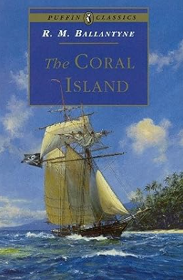
When the three sailor lads, Ralph, Jack and Peterkin are cast ashore after the storm, their first task is to find out whether the island is inhabited. Their next task is to find a way of staying alive. They go hunting and learn to fish, explore underwater caves and build boats - but then their island paradise is rudely disturbed by the arrival of pirates.
Lord of the Flies was directly inspired by R.M. Ballantyne's 1857 novel The Coral Island, with William Golding subverting its optimistic view of British colonialism to explore the innate capacity for evil within children.

