Group: EW08 |  |  | Subject: English | Term: 1 | Step: 5
Teacher: |  | Angus Spencer
Curriculum: Secondary Two Fundamentals
Term 1 focus:
HT1 - Novel – Of Mice and Men
HT2 - Fact and Fiction in Context
This term, our studies will centre on developing both reading and writing skills through a comprehensive study of Of Mice and Men by John Steinbeck and a selection of high-quality 19th Century non-fiction extracts.
In reading, we will develop our ability to respond to a range of texts with insightful comments, using contextual knowledge and quotations to support ideas and representations, grounding responses in secure textual evidence. Students will explore meanings and interpretations within the text, including both explicit and implicit ideas, and beginning to analyse these in greater depth while reading the novella. Students will also examine how writers use structural choices to shape meaning and support their themes or purposes for example using a cyclical structure. We will also analyse language choices to understand their overall impact on readers and engage in discussions about how context influences interpretation.
In writing, we will focus on both an analytical lens and an expressive lens. In HT1, we will be answering a question of analysis of a key theme and completing a summative expressive task about the ending of the novella. We then move on to use a suitable level of formality for different purposes and audiences, as well as incorporating a variety of stylistic devices to enhance our writing as we work on making these choices more effective. Students will learn to clearly signal the overall direction of their texts, ensuring that paragraph construction supports meaning and purpose. We will also work on achieving accuracy in syntax and punctuation across various sentence structures, while expanding our vocabulary to include a range of varied and ambitious word choices.

Reading:
HT1: Understanding the text and using evidence
HT2: Situating the text in culture

KO2 | I can identify most relevant points from various places. I support comments and ideas with relevant references or quotations.
KO3 | I infer meanings from varied evidence across the text. My comments develop explanations of these.
KO5 | I can identify language features which the writer has chosen to use and develop some explanation of them.
KO6 | I can clearly identify main purpose & perspectives. Have an overview of text. Can generally explain effect on reader.
KO7 | I can identify similarities, differences between texts with some explanation. Also how contexts contribute to meaning.
KO8 | I can summarise & evaluate. I show accurate understanding. Valid, consistent responses to meanings & viewpoints.
Writing:
HT1: Accuracy
HT2: Transactional writing focus

KO2 | My purpose is clear and features of the form are adapted to the purpose. My appropriate style maintains the reader’s interest.
KO3 | I structure clearly w paragraphs. I develop material. I signal direction by links between paragraphs
KO4 | I use paragraphs etc to structure writing & achieve purpose. Links between paragraphs more developed

Tier Three Keywords:
infer | identify | audience | allusion | cyclical
evaluate | purpose | present | setting | analyse
context | character | allegory | dreams | prejudice

Recommended Reading:

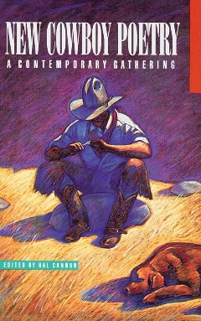

New Cowboy Poetry: a Contemporary Gathering by Hal Cannon

The modern and revolutionary collection of cowboy poetry has become a cultural phenomenon in the West, and it's spreading like wildfire across the country. Most western states hold their own gatherings each year, where ranching men and women recite poems written about their way of life.

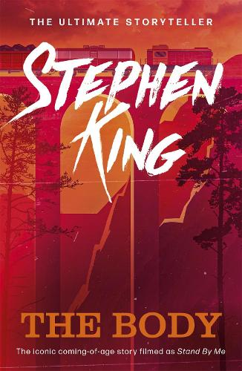

The Body by Stephen King

The Body, follows four boys—Gordie, Chris, Teddy, and Vern—on a fateful journey in the summer of 1960 to find the body of a missing boy, a quest that becomes a profound coming-of-age experience exploring themes of friendship, mortality, and the loss of innocence as they confront their fears and the harsh realities of the world.

