Group: Geography S2E |  |  | Subject: Humanities | Term: 1
Teacher: |  | Amy Cushing
Curriculum: GCSE Geography Year 1
Term 1 focus:

HT1 – Ecosystems (overview and tropical rainforests)
HT2 – Ecosystems (temperate deciduous woodlands)

Students learn an overview of global ecosystems including location and factors that influence that ecosystem. In half term 1 - students then focus on tropical rainforests and learn about key physical components and also impacts due to human activity. Students learn about a case study example of sustainable management of a tropical rainforest. In half term 2, students focus on a second ecosystem, temperate deciduous woodlands. This is one of the main ecosystems of the UK and allows students to learn about the management of a nearby example.

1 | Overview of global ecosystems
2 | Factors that influence ecosystems
3 | Physical processes in ecosystems
4 | Plant and animal adaptions in ecosystems
5 | The value of ecosystems
6 | Ecosystem case studies: tropical rainforests
7 | Ecosystem case studies: temperate deciduous woodlands
8 | Causes of deforestation
9 | Sustainable management of ecosystems
10 | How climate change affects ecosystems

Tier Three Keywords:
ecosystem | temperate | goods | services | latitude | Adaptation
biodiversity | sustainable | management | nutrient | Gersmehl | deforestation
Global atmospheric circulation |  |  | vegetation | canopy | Emergent

Recommended extra materials

https://www.bbc.co.uk/bitesize/guides/zwy7sg8/revision/1

https://education.nationalgeographic.org/resource/rain-forest/

https://www.rainforestconcern.org/forest-facts/why-are-rainforests-being-destroyed

https://timeforgeography.co.uk/video-collections/ecosystems/

https://visitsherwood.co.uk/

Watch - A Life on Our Planet by David Attenborough on Netflix

Planet Earth and Seven Worlds One Planet on BBC iplayer

Book – A Life on Our Planet by David Attenborough

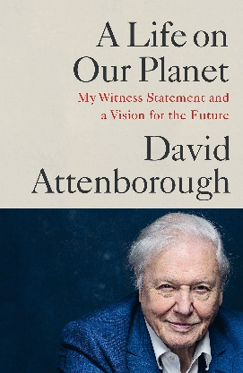

 |  | Attended
1 | Overview of global ecosystems
2 | How climate influence ecosystems
3 | How local factors influence ecosystems
4 | What resources humans use from the biosphere
5 | What are the main UK ecosystems
6 | What are marine ecosystems
7 | Plant adaptions in tropical rainforests
8 | Animal adaptions in tropical rainforests
9 | Physical processes in tropical rainforests
10 | The value of tropical rainforests
11 | Ecosystem case studies: tropical rainforests in Costa Rica or Brazil
12 | Causes of deforestation in tropical rainforests
13 | Impacts of deforestation in tropical rainforests
14 | Sustainable management of tropical rainforests
15 | How climate change affects tropical rainforests



