AS |  | Biology |  | Term 1  Sept-Dec 2025
Teacher : Nayna |  |  | Review GCSE knowledge and move into extending to a higher level.
CELLS

All life on Earth exists as cells. These have basic features in common. Differences between cells are due to the addition of extra features. This provides indirect evidence for evolution.

*All cells arise from other cells, by binary fission in prokaryotic cells and by mitosis and meiosis in eukaryotic cells. (Basic introduction, build on later)

*All cells have a cell-surface membrane and, in addition, eukaryotic cells have internal membranes. The basic structure of these membranes is the same and enables control of the passage of substances across exchange surfaces by passive or active transport.

Cell-surface membranes contain embedded proteins. Some of these are involved in cell signalling – communication between cells. Others act as antigens, allowing recognition of ‘self’ and ‘foreign’ cells by the immune system. Interactions between different types of cells are involved in disease, recovery from disease and prevention of symptoms occurring at a later date if exposed to the same antigen, or antigen-bearing pathogen.

1 | Structure of Eukaryotic cells  The structure of eukaryotic cells, restricted to the structure and function of:  *Cell-surface membrane  *Nucleus (containing chromosomes, consisting of protein-bound, linear DNA, and one or more nucleoli)  *Mitochondria  *Chloroplasts (in plants and algae)  *Golgi apparatus and Golgi vesicles  *Lysosomes (a membrane-bound organelle that releases hydrolytic enzymes)  *Ribosomes  *Rough endoplasmic reticulum and smooth endoplasmic reticulum  *Cell wall (in plants, algae and fungi)  *Cell vacuole (in plants).  In complex multicellular organisms, eukaryotic cells become specialised for specific functions. Specialised cells are organised into tissues, tissues into organs and organs into systems.  (Students should be able to apply their knowledge of these features in explaining adaptations of eukaryotic cells.)
2 | Specialised cells: Examples, structure and function for both plant and animal examples:  *Ciliated cells *Muscle cells * Nerve cells *Blood cells  * Reproductive cells  *Stomata *Root hair cells *palisade cells, xylem cells, phloem cells * ovule* red blood cells * white blood cells.
3 | Structure of Prokaryotic cells  Prokaryotic cells are much smaller than eukaryotic cells. They also differ from eukaryotic cells in having:  *Cytoplasm that lacks membrane-bound organelles  *Smaller ribosomes  *No nucleus; instead they have a single circular DNA molecule that is free in the cytoplasm and is not associated with proteins  *A cell wall that contains murein, a glycoprotein.  In addition, many prokaryotic cells have:  *One or more plasmids  *A capsule surrounding the cell  *One or more flagella.  (Details of these structural differences are not required.)
4 | Organisation of cells into tissues, organs and systems.  *Cell: the smallest structural and functional unit of an organism, which is typically microscopic and consists of cytoplasm and a nucleus enclosed in a membrane.  Tissue: a group of cells that have similar structure and that function together as a unit.  Eg:  Tissue Type Location  *Epithelial Skin, lining of hollow organs  *Connective Blood, bone, fat, cartilage, extracellular  matrix  *Muscle Skeletal muscle, heart, inner layers  of hollow organs  *Nervous Brain, spinal cord, nerves  Organ: a collection of tissues that structurally form a functional unit specialized to perform a particular function.  Eg. heart, kidneys, and lungs are examples of organs.  System: A structure made up of groups of different tissues, working together to perform specific functions. Organ system. A group of organs with related functions, working together to perform certain functions within the body.  Systems on the body: for each name the specialised cells. organs and additional components which make up the system.  - Skeletal System,  - Muscular System,  - Nervous System,  - Endocrine System,  - Cardiovascular System,  - Lymphatic System,  - Respiratory System,  - Digestive System,  - Urinary System,  - Reproductive System (Female and Male).
5 | *Structure of Viruses  Viruses are acellular and non-living. The structure of virus particles to include genetic material, capsid and attachment protein.  Diagram of structure:  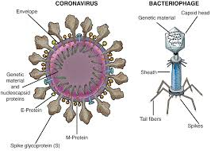
6 | Methods of studying Cells.:  - Use of the microscope  History: Anton van Leeuwenhoek. The Simple microscope  Research activity:  Research the history of the study of cells.  - Parts of a microscope.  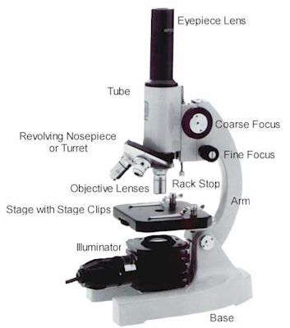  *The electron microscope:  An electron microscope is a microscope that uses a beam of electrons as a source of illumination. They use electron optics that are analogous to the glass lenses of an optical light microscope to control the electron beam, for instance focusing them to produce magnified images or electron diffraction patterns. As the wavelength of an electron can be up to 100,000 times smaller than that of visible light, electron microscopes have a much higher resolution of about 0.1 nm, which compares to about 200 nm for light microscopes.  *Identifying slides/histology of plants and animals.  Practical on use of microscope and identifying slides.
7. | Magnification = size of image / size of real object  - Examples and application.
8. | The importance of cell division for both growth and reproduction
9 | Mitosis & Meiosis; two types of cell division
10 | Mitosis:  Mitosis is a process of cell duplication, in which one cell divides into two genetically identical daughter cells. In the various stages of mitosis, the cell's chromosomes are copied and then distributed equally between the two new nuclei of the daughter cells which are identical cells with a complete set of chromosomes in each. Growth and repair.  Stages: Interphase, Prophase, Metaphase, Anaphase and Telophase (Notes and diagrammatic representation.)  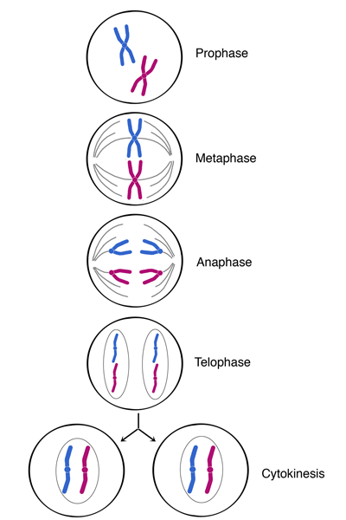  Cytokinesis; Cell splits  2 diploid identical daughter cells produced  Growth and replacement of cells
11 | Meiosis: Cell division resulting in the production of daughter cells containing only half the number of chromosomes. (Notes and diagrammatic representation of the stages essential)  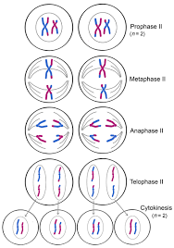  Cytokinesis: Cell splits  4 haploid unique daughter cells produced  Sexual Reproduction and variation  - Meiosis creates new combinations of genetic material in each of the four daughter cells. These new combinations result from the exchange of DNA between paired chromosomes. Such exchange means that the gametes produced through meiosis exhibit an amazing range of genetic variation. Crucial for adaption and survival.
12 | Required practical 1:  Preparation of stained squashes of cells from plant root tips; set-up and use of an optical microscope to identify the stages of mitosis in these stained squashes and calculation of a mitotic index.  Students should measure the apparent size of cells in the root tip and calculate their actual size using the formula:  Actual size = size of image/ magnification  Required practical 2:  Production of a dilution series of a solute to produce a calibration curve with which to identify the water potential of plant tissue.  Required practical 3:  Investigation into the effect of a named variable on the permeability of cell-surface membranes.  ASSESSMENT:  Through recall and responding to past exam questions as well as supportive questions which test knowledge and understanding.

