Group: AS level Biology Year 2 |  |  | Subject: AS level Biology | Term: 1
Teacher: |  | Milly Latham
Curriculum: Study programme 3 - AS level Biology
Term 1 focus: Organisms exchange substances with their environment |  |  |  |  | RAG rating  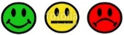
1 | Explain how the surface area to volume ratio affects the rate of exchange in organisms.
2 | Relate the size and metabolic rate of an organism to its requirement for specialised exchange surfaces.
3 | Single-celled organisms: Describe how single-celled organisms exchange gases directly with their environment.
4 | Insects: Describe the structure of the tracheal system, and explain how gases are exchanged in insects
5 | Fish: Describe the structure of fish gills and explain the counter-current mechanism that enables efficient gas exchange.
6 | Plants: Describe the structure of a dicotyledonous leaf and explain how leaves are adapted for efficient gas exchange.
7 | Terrestrial adaptations: Explain the adaptations of terrestrial insects and xerophytic plants to balance the conflicting needs of gas exchange and water loss.
8 | Gross structure: Describe the gross structure of the human gas exchange system, including the trachea, bronchi, bronchioles, lungs, diaphragm, and alveoli.
9 | Alveoli structure: Explain the essential features of the alveolar epithelium that make it an efficient gas exchange surface.
10 | Ventilation mechanism: Describe and explain the mechanism of breathing (ventilation), including the role of the diaphragm and intercostal muscles in changing the pressure within the thoracic cavity.
11 | Lung disease: Interpret information relating to the effects of lung disease (such as asthma, emphysema, and fibrosis) on gas exchange.

Tier Three Keywords:
Exchange surface | Active transport | Tracheoles | Countercurrent | Circulatory
Diffusion | Concentration gradient | Spiracles | Ventilation | arteries
Osmosis | Surface area | Lamellae | diaphragm | bronchioles
medium | correlation | adaptations | emphysema | intercostal

Recommended Reading:

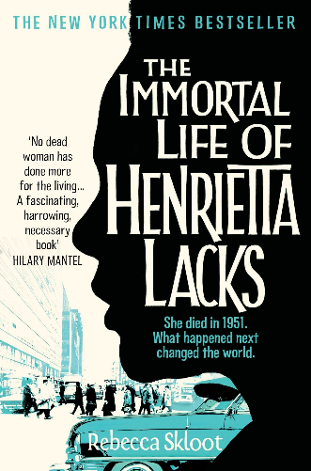
The Immortal Life of Henrietta Lacks by Rebecca Skloot:

This book tells the captivating story of Henrietta Lacks, whose cancer cells were taken without her knowledge and became one of the most important tools in medicine. It’s a powerful narrative that explores ethics, race, and the history of medicine

