Group: BR SFD Specialism 3 |  |  | Subject: Computing |  | Term: 1  01.09.25 – 19.12.25
Teacher: |  | Enike
Curriculum: BR SFD Specialism 3
BTEC FIRST AWARD: Information and Creative Technology

Term 1 focus: Unit 6 Creating Digital Graphics: Learning Aim 3
Students continue to work on their Unit 6 assignments and focus on learning Aim 3.
In this unit, students will explore the fundamentals of digital graphics and how they are used in a variety of digital media applications. Students will learn about the different types of graphics (bitmap and vector), image resolution, file formats, and the impact of graphic design on communication and user engagement.
Throughout the unit, students will develop key technical and creative skills using graphic design software such as Adobe Photoshop, GIMP, or an equivalent. They will learn to plan, design, and create digital graphics for a specific audience and purpose.
In learning aim 3 students are to create, review and test their digital graphic products in alignment with the Unit 3 assignment brief. Students will aim to accomplish all tasks detailed in the vocational scenario outlined in the assignment.
 | Objective |  |  | Attendance |  | How do you feel about it after the lesson
1 | I am able to create original digital graphics such as vector and bitmap images using image editing /drawing software |  |  | I was in attendance when this was taught? |  | G = Good  B = Bad  N = Need more support
2 | I can use graphics software to practice editing techniques such as: adding text, shading, add effects, group images, rotate, duplicate and layer images
3 | I know how to compress and export an image file
4 | I can use my skills and knowledge to formulate an opinion about what good quality graphic products look like, being able to formulate a professional opinion
5 | I am able to correctly review the quality, fitness, purpose, sustainability, strengths and weaknesses of a graphic product
6 | I understand the legal and ethical constraints of graphic products

Tier Two and Tier Three Keywords:
Bitmap | Vector | Graphics | Compression | Photo Editing | Product brief
Resolution | Application | Drawings | Manuals | User Guide | Advert
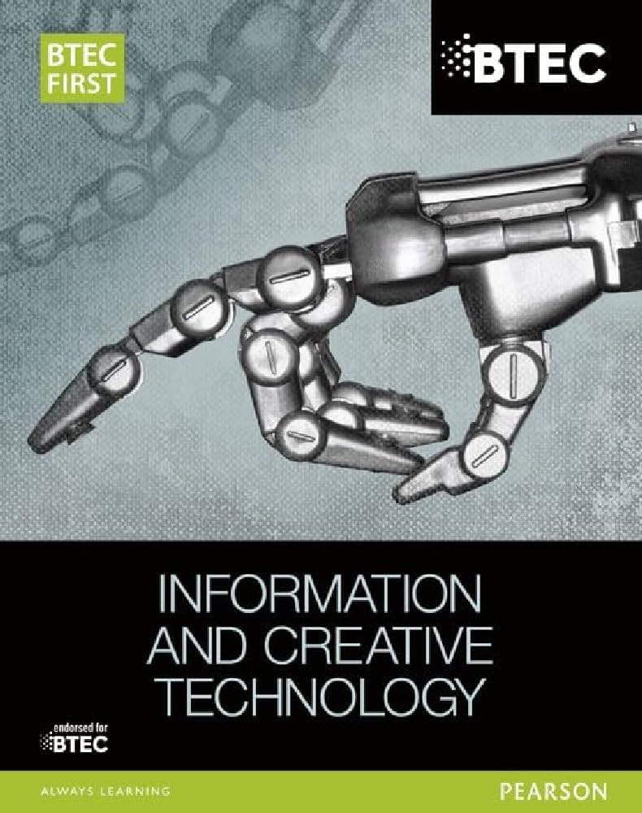 Recommended Reading:
This is the BTEC FIRST book that is related to this module and students would get a lot of useful information from this book that would prepare them for the BTEC Qualification

Assessment
Formative | Summative
Formative assessments will be done throughout the Computing lessons.  The start of the lesson will have DNA set out for memory recall. There will be questioning during modelling, encouraging students to explain and justify their working as well as checking work.  There will also be exit tickets used at intervals during the course of study for each module | Students will be given assessments for each module that will be a summary of what they have been learning. Through these assessments students will be able to showcase their knowledge and how much they are retaining in their long-term memory  Assignments will be marked internally and given back to the students to make improvements where needed  This will inform further term planning where lessons are concerned and expose any misconceptions and misunderstandings.

