Group: EW S2E Specialism 3 Year |  |  | Subject: Computing |  | Term: 2  01/09/25 – 19/12/25
Teacher: |  | Enike
Curriculum: EW S2E Specialism 3
BTEC FIRST INFORMATION & CREATIVE TECHNOLOGY
Term 1 focus: The Online World
How do websites work? How do emails reach your computer? How does the use of
computer applications affect your daily life? This unit provides an introduction to the
modern online world. Starting with your own experiences, you will extend your
knowledge of online services and investigate the technology and software that
supports them. You will learn more about a range of services including email,
online data storage, collaborative software, search engines and blogging.

 | Outcome |  |  | Attendance |  | How do you feel about it [end of lesson]
 |  |  |  | Where you in attendance when taught? Y/N |  | G = Good  B = Bad  N = Need more support
1 | Be able to understand communication such as email, instant messaging, newsgroups, social networking, online conferencing, blogs, chat room etc.)
2 | Identify how to collate real-time information (train timetables, news services, traffic reports, flight status updates and weather)
3 | Analyse the use of E-commerce (internet banking, online auction websites, retail sales, publishing)
4 | Understand Government lead services online such as (online tax returns, e-voting, applications for services/grants and revenue collection)
5 | Explain the use of educational services online such as (online learning/training, virtual learning environments)
6 | Understand how to compress (.zip) files for download/upload
7 | Explain the advantages of using online software to create documents, including collaborative working, sharing documents and automatic backup
Tier Two and Tier Three Keywords:
Online | Virtual | Social Networking | Collaborative | Files | Download
Upload | .Zip | Software | Social Media | Applications | Messaging
Privacy | Profile | Chat | E-commerce | Emails | Cloud computing
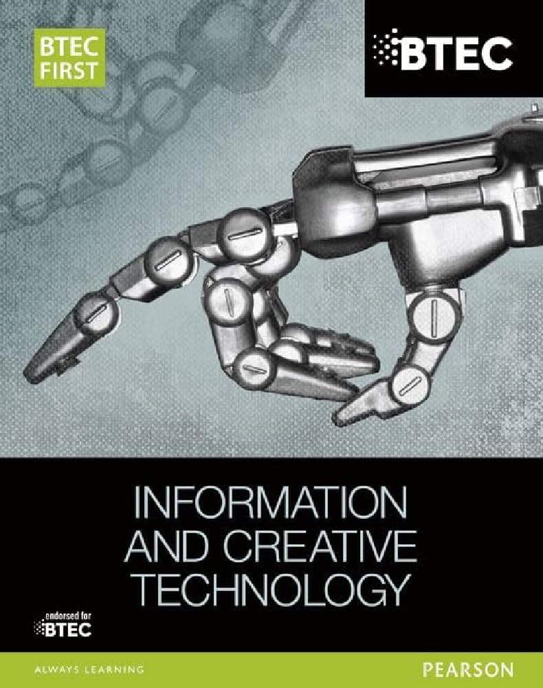
This is the BTEC FIRST book that is related to this module and students would get a lot of useful information from this book that would prepare them for the BTEC Qualification
Recommended Reading:
Assessment

Formative | Summative
Formative assessments will be done throughout the Computing lessons.  The start of the lesson will have DNA set out for memory recall. There will be questioning during modelling, encouraging students to explain and justify their working as well as checking work.  There will also be exit tickets used at intervals during the course of study for each module. | Students will be given assessments for each module that will be a summary of what they have been learning. Through these assessments students will be able to showcase their knowledge and how much they are retaining in their long-term memory  This will inform further term planning where lessons are concerned and expose any misconceptions and misunderstandings.

