Group: EW08 |  |  | Subject: Computing |  | Term: 1  01.09.25 – 19.12.25
Teacher: |  | Enike
Curriculum: Computing

Term 1 focus: Digital Literacy & E-Safety

Digital Literacy:
In this module students will learn the essential skills needed to navigate and use technology effectively and safely. Key areas covered include:
Basic computer skills – Understanding how to log into a computer and navigate through the user interface; students will be able to log in to a computer, open essential office 365 programmes, learn how to save their work and understand how to create folders on their personal drives.

Effective use of programmes: students will get to use and navigate their way through Microsoft Word, PowerPoint and Excel. They will also learn how to write emails and send emails with attachments

Internet Navigation: Using search engines, evaluating online information, and understanding the structure of the internet.
This module will aim to equip students with the knowledge and skills to confidently participate in the digital world, both academically and personally

E-Safety
This e-safety module is designed to help students understand how to stay safe, responsible, and respectful while using the internet and digital devices. The lessons cover key areas such as online privacy, cyberbullying, digital footprints, and the importance of critical thinking when interacting with content or people online.
Students will learn:
- How to protect their personal information and manage privacy settings on social media and websites.
- The risks of sharing content online and how it can affect their digital reputation.
- How to recognise, respond to, and report cyberbullying and online harassment.
- The importance of strong passwords and secure online behaviour.
- How to spot misinformation, scams, and suspicious online behaviour.
Through interactive discussions, real-life scenarios, and practical activities, students will develop the knowledge and confidence to make safe and informed decisions in the digital world

 | Objective |  |  | Attendance |  | How do you feel about it after the lesson
1 | I can comfortably navigate through the user interface of a computer, knowing how to access documents, emails, applications and more |  |  | I was in attendance when this was taught? |  | G = Good  B = Bad  N = Need more support
2 | I am able to change text, font, colours and add images to a PowerPoint
3 | I am able to use slide master, create hyperlinks and add videos and sound to a PowerPoint
4 | I am able to use the Inbuilt PowerPoint Animations and Transitions to modify my PowerPoint slides
5 | I can open up an excel spreadsheet and navigate easily through a spreadsheet
6 | I am able to add text, numbers and formulas to a spreadsheet
7 | I am able to perform basic functions such as addition, subtraction, division and multiplication on Excel
8 | I am able to display patterns of data through chats in excel and I am able to calculate the minimum, maximum and mean in excel with raw data
11 | I am able to open and create a basic word document and use functions in word such as [text, font style, colour and font size]
12 | I can use the tool bar effectively and know how to use it to manipulate a word document
15 | I can create an email and send it with an attachment and I can identify what the abbreviations [to, cc and bcc] stand for on an email

Tier Two and Tier Three words:
Excel | PowerPoint | Word | Formula | Hyperlink | Animations
Spreadsheets | Attachments | Emails | Applications | Documents | Transitions
Functions | Master Slide | Copy and Paste | Save | Data | Charts
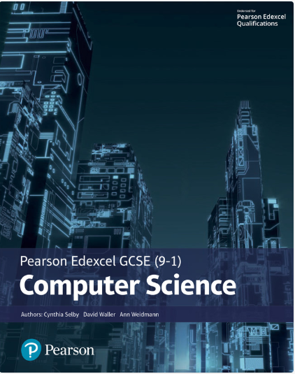The Pearson Edexcel GCSE (9-1) Computer Science 2020 student book offers:
- plenty of practical activities for programming that follow the PRIMM pedagogy
- real world examples and case studies of Computer Science in Action to help make the content relevant and inspiring to students
- worked examples and activities using the PLS or ‘Programming Language Subset’ (Python) for a simple and comprehensive approach to programming
- simplified content to make it as accessible as possible.
This Student Book also helps students concise and productive exam preparation.
Recommended Reading

Assessment

Formative | Summative
Formative assessments will be done throughout the Computing lessons.  The start of the lesson will have DNA set out for memory recall. There will be questioning during modelling, encouraging students to explain and justify their working as well as checking work.  There will also be exit tickets used at intervals during the course of study for each module | Students will be given assessments for each module that will be a summary of what they have been learning. Through these assessments students will be able to showcase their knowledge and how much they are retaining in their long-term memory  This will inform further term planning where lessons are concerned and expose any misconceptions.  For this Module students will be asked to create a PowerPoint with a specification that will showcase their skills

