Groups: C06, C07 &  C08 |  |  | Subject: Drama and Oracy | Term: 1
Teacher: |  | Lizzie
Curriculum: Deepening KS3.
Term 1 focus: Introduction to BTEC Drama
1 | Join in with activities to develop confidence and deepen understanding of performance techniques
2 | Understand and apply vocal and physical skills to create a character or presentation
3 | Demonstrate reciprocal working in a pair or group
4 | Show applied work to peers via performance or presentation
5 | Share ideas to develop a storyline to use within a devised performance
6 | Deepen understanding of story through researching information and add findings into devised performance
7 | Give positive and constructive feedback to support peers during the development and performance process
8 | Understand how to structure and write a script
9 | Apply performance skills and/or design skills to work out how to make the devised performance suitable for a stage
10 | Find Given Circumstances within a scripted scene

Tier Three Keywords:
Vocal | Physical | Script | Explorative | Setting | Props
Perform | Devise | Improvise | Given Circumstance | Character | Audience
Direct | Expression | Intonation | Body Language | Context | Design

Recommended Reading (and watching):

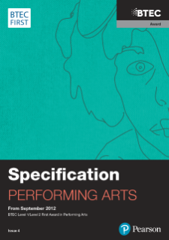 BTEC First Award in Performing Arts Specification

