Group: M01 |  |  | Subject: Performing Arts | Term: 1
Teacher: |  | Natalie Wood
Curriculum: Secondary Ready Induction
Term 1 focus: Introduction to Performing Arts
1 | Join in with activities and games to develop confidence
2 | Understand vocal skills such as pause/silence, pace, tone & volume.
3 | Use vocal skills such as pause & silence, pace, tone, volume.
4 | Understand physical skills such as facial expressions, body language and gestures.
5 | Use physical skills such as facial expressions, body language and gestures.
6 | Demonstrate reciprocal working in a pair or group
7 | Show applied work to peers via performance or presentation
8 | Understand and demonstrate linguistic skills in presenting
9 | Give positive and constructive feedback to support peers during practical assessments

Tier Three Keywords:
Dialect | Accent | Pedagogical | Presentational | Tension | Suspense
Perform | Present | Volume | Soundscape | Reaction | Audience
Tone | Expression | Intonation | Body Language | Gesture | Pace

Recommended Reading (and watching):

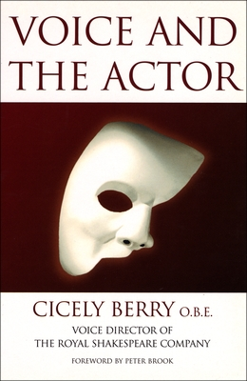
Cicely Berry’s classic guide explores how to use the voice with confidence and clarity. Covering breath, tone, pitch, pause, and pace, it offers practical exercises to unlock expression and communication. Essential for anyone wanting to develop vocal skills for performance, presentation, or everyday confidence.

