Group: B11/ 6th Form English BR |  |  | Subject: English | Term: 1
Teacher: |  | Molly Vellacott
Curriculum: Sixth Form Deepening (Step 5)
Term 1 focus:
HT1 - Novel – Memory Thieves
HT2 - Fact and Fiction in Context
This term our studies will centre on developing both reading and writing skills through a comprehensive study of Memory Thieves and a selection of high-quality non-fiction and descriptive extracts from the Victorian era.

In reading, we will enhance our ability to support main ideas with appropriate textual references and quotations. Students will delve into the layers of meaning within texts. We will also analyse language choices to understand their overall impact on readers and engage in discussions about how context influences interpretation. A key focus will be on effectively responding to both explicit and implicit meanings.

In writing, we will focus on using a suitable level of formality for different purposes and audiences, as well as incorporating a variety of stylistic devices to enhance our writing as we work on making these choices more effective. Students will learn to clearly signal the overall direction of their texts, ensuring that paragraph construction supports meaning and purpose.

Reading:
HT1: Understanding the text and using evidence
HT2: Situating the text in culture

KO2 | I can identify most relevant points from various places. I support my comments and ideas with generally relevant textual references or quotations.
KO3 | I infer meanings from varied evidence across the text. My comments develop explanations of these.
KO5 | I can identify language features which the writer has chosen to use and develop some explanation of them.
KO6 | I can clearly identify the author’s main purpose and perspectives and have a general overview of the text. I am aware of and can generally explain effect on reader.
KO7 | I can identify similarities, differences between texts with some explanation. Also how contexts contribute to meaning.
KO8 | I can summarise & evaluate. I show accurate understanding. Valid, consistent responses to meanings & viewpoints.
Writing:
HT1: Accuracy
HT2: Transactional

KO2 | My purpose is clear and features of the form are adapted to the purpose. My appropriate style maintains the reader’s interest.
KO3 | I control & sequence writing taking account of reactions. Range of features clearly signal direction.
KO4 | Paragraphs and other devices structure my writing to achieve its purpose. Links between paragraphs are more developed.

Tier Three Keywords:
Self-concept | Chronological | Entertain/ engage | Friendship/ isolation
Limited perspective | analepsis | Tension/ suspense | Heterodiegetic narrator
foreshadowing | Science fiction | neology | Structure

Recommended Reading:
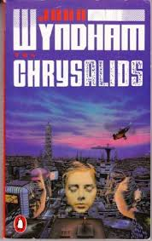
The Chrysalids by John Wyndham
In this post-apocalyptic novel we enter a world in which unexpected genetic mutations are common, but demonised. We follow the fate of a group of young people who share the most dangerous mutation of all as they attempt to keep it hidden. Wyndham explores themes of marginalisation, extremism, and the possibilities afforded to humans when they are able to embrace change and difference. Its focus on the mind and identity make it a great choice for readers wanting to extend their reading from Memory Thieves.

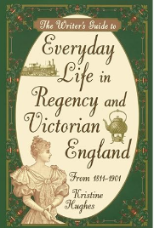

The Writer’s Guide to Everyday Life in Regency and Victorian England by Kristine Hughes

A study of everyday life in Victorian England taken from anecdotes, written histories and first-hand accounts.

