Group: BTEC Y1 |  |  | Subject: Music | Term: 1
Teacher: |  | Rae
Curriculum: Secondary 2 Exploring
Term 1 focus(es): Component 1: Understanding Music
The areas of study provide an appropriate focus for students to appraise, develop and demonstrate an in-depth knowledge and understanding of musical elements, musical context and musical
language. The four areas of study can also provide a rich source of material for to work with when developing performance and composition skills.

A0S1: Western Classical Tradition 1650-1910:
Students will develop an understanding of the western classical tradition; defined as art music of (or growing out of) the European tradition, normally notated, and normally intended for public performance. Students will be able to listen attentively to unfamiliar music from the following styles/genres to identify and accurately describe musical elements, musical contexts and musical language:
• The Coronation Anthems and Oratorios of Handel.
• The Orchestra Music of Haydn, Mozart and Beethoven.
• The piano music of Chopin and Schumann.
• The Requiem of the late Romantic period.
Students will also develop a good knowledge and understanding of the musical features of the following set work:
Beethoven: Symphony No.1, Movement 1: Adagio molto – Allegro con brio

A0S2: Popular Music
Students will explore a number of musical styles and genres including rock, pop, musical theatre, film and computer gaming music from 1950 to the present. Students will be able to listen attentively to unfamiliar music from the following styles/genres to identify and accurately describe musical elements, musical contexts and musical language:
• music of Broadway 1950s to 1990s
• rock music of 1960s and 1970s
• film and computer gaming music 1990s to present
• pop music 1990s to present.
Students will also develop a good knowledge and understanding of the musical features of the following set works:
Queen – the following three tracks:
• Bohemian Rhapsody
• The Seven Seas of Rhye
• Love of my Life

This term will focus on rock music of 196s and 1970s.

1 | Know what DR SMITH stands for and understand each musical elements (dynamics, rhythm, structure, metre/melody, instrumentation, tonality/texture/timbre/tempo, harmony).
2 | Actively listen to unfamiliar music and identify and describe its musical elements using DR SMITH.
3 | Know the musical contexts for the works of key Baroque, Classical and Romantic composers. (Handel, Haydn, Mozart, Beethoven, Chopin, Schumann)
4 | Identify the key musical elements of a variety of styles of rock music
5 | Know the context for key rock artists of the 196s and 1970s including the Beatles, The Kinks, The Rolling Stones, Queen
6 | Use correct musical language to describe the musical elements of a piece of music
7 | Develop basic score reading skills using western traditional musical notation.
8 | Build confidence using DAWs such as BandLab and GarageBand
9 | Reflect on own creative practise

Tier Three Keywords:
Dynamics | Rhythm | Structure | Metre | Melody | Instrumentation
Texture | Timbre | Tonality | Tempo | Harmony | Baroque
Classical | Romantic | Metal | Punk rock | Prog rock | Psychedelic
Half Term 1 Assessment
Daily Assessment | Substantive Assessment
- Active listening activities
- Class discussions
- Building a portfolio of composition ideas
- Starter recall questions

Half Term 2 Assessment
Daily Assessment | Substantive Assessment

Recommended Reading (and Listening):

The Complete Beatles Songs: The Stories Behind Every Track Written by the Fab Four (Stories Behind the Songs) by Steve Turner.
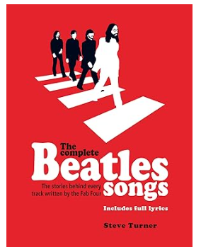
In The Complete Beatles Songs, Steve Turner shatters many well-worn myths and adds a new dimension to the Fab Four's rich legacy.
This beautifully packaged book examines every Beatles-penned song and the inspiration behind them all; with fresh research and packed with new information, there are revelations aplenty. The book covers the Fab Four's entire output chapter by chapter and includes a complete set of printed lyrics to accompany each song, used with exclusive permission from the band's music publishers.
Who was 'just seventeen' and made Paul's heart go 'boom'? Who was 'Lady Madonna'? Was there really an Eleanor Rigby? What inspired 'Happiness is a Warm Gun'? Why was Paul the 'walrus' and what inspired the lyrics to Ringo's 'Octopus's Garden'?
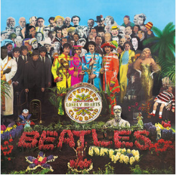

Seargent Pepper’s Lonely Heart’s Club Band by The Beatles

Sgt. Pepper's Lonely Hearts Club Band is the eighth studio album by the English rock band the Beatles. Released on 26 May 1967. It is credited as the first ever concept album.
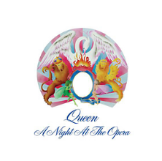

A Night at the Opera by Queen

A Night at the Opera is the fourth studio album by the British rock band Queen, released on 28 November 1975, by EMI Records in the United Kingdom and Elektra Records in the United States. Produced by Roy Thomas Baker and Queen, it was reportedly the most expensive album ever recorded at the time of its release.

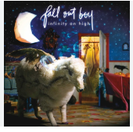
Infinity High by Fallout Boy

Infinity on High is Fall Out Boy's third major label album, released on February 6, 2007, with alternative rock, pop, pop punk, and pop rock genres

