Group: BTEC Y1 |  |  | Subject: Music | Term: 1
Teacher: |  | Rae
Curriculum: Secondary 2 Exploring
Term 1 focus(es): Component 1: Exploring Music Products and Styles
Learning aims
A Demonstrate an understanding of styles of music
B Apply understanding of the use of techniques to create music

Through focused listening and music-making activities, students will explore a variety of musical styles and understand the key features of different styles of music and their use of musical elements. They will also learn how to apply stylistic features to performance, composition and music production activities.

1 | Understand how technology has impacted musical styles, instruments, production and recording.
2 | Explore the work of a variety of artists, bands, composers and producers who have influenced and impacted musical styles
3 | Know the musical elements, stylistic features and characteristics of at least 3 styles of popular music.
4 | Know the musical elements, stylistic features and characteristics of at least 2 styles of music outside of popular music.
5 | Use correct musical language to describe the musical elements of a piece of music
6 | Consider the impact of a piece of music for the purpose it was created for.
7 | Experiment with creating music in a variety of styles.
8 | Experiment with a variety of different techniques to create music.
9 | Reflect on own creative practise

Tier Three Keywords:
DAW (Digital Audio Workstation) | Composition | Foley | Instrumentation | texture | Timbre
tonality | harmony | rhythm | structure | melody | production
Half Term 1 Assessment
Daily Assessment | Substantive Assessment
- Active listening activities
- Class discussions
- Building a portfolio of composition ideas
- Starter recall questions

Half Term 2 Assessment
Daily Assessment | Substantive Assessment
- The assignment for Component 1 consists of two tasks. ​
- In response to Task 1, learners will compile a portfolio of evidence that demonstrates their understanding of four different styles of music using musical examples related to a theme. ​
- In response to Task 2, learners will create three 30–60-second examples of ideas for music products related to a theme, using a range of realisation techniques. ​
- The assignment will take approximately 12 supervised hours to complete. ​

Recommended Reading (and Listening):

The Complete Beatles Songs: The Stories Behind Every Track Written by the Fab Four (Stories Behind the Songs) by Steve Turner.
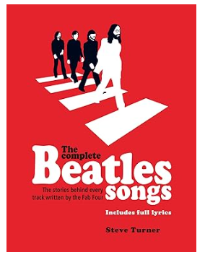
In The Complete Beatles Songs, Steve Turner shatters many well-worn myths and adds a new dimension to the Fab Four's rich legacy.
This beautifully packaged book examines every Beatles-penned song and the inspiration behind them all; with fresh research and packed with new information, there are revelations aplenty. The book covers the Fab Four's entire output chapter by chapter and includes a complete set of printed lyrics to accompany each song, used with exclusive permission from the band's music publishers.
Who was 'just seventeen' and made Paul's heart go 'boom'? Who was 'Lady Madonna'? Was there really an Eleanor Rigby? What inspired 'Happiness is a Warm Gun'? Why was Paul the 'walrus' and what inspired the lyrics to Ringo's 'Octopus's Garden'?
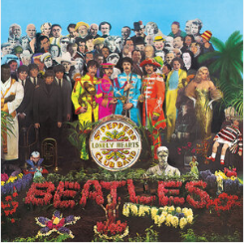

Seargent Pepper’s Lonely Heart’s Club Band by The Beatles

Sgt. Pepper's Lonely Hearts Club Band is the eighth studio album by the English rock band the Beatles. Released on 26 May 1967. It is credited as the first ever concept album.
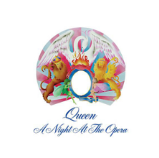

A Night at the Opera by Queen

A Night at the Opera is the fourth studio album by the British rock band Queen, released on 28 November 1975, by EMI Records in the United Kingdom and Elektra Records in the United States. Produced by Roy Thomas Baker and Queen, it was reportedly the most expensive album ever recorded at the time of its release.

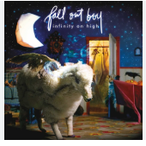
Infinity High by Fallout Boy

Infinity on High is Fall Out Boy's third major label album, released on February 6, 2007, with alternative rock, pop, pop punk, and pop rock genres

