Group: C09 and C10 |  |  | Subject: English | Term: 2
Teacher: |  | Helen Hawkins and Liz Lynch Smith
Curriculum: Secondary Two Exploring
Term 2 focus:
HT1: Short Stories and Creative Writing
We will read a small selection of short stories in order to explore conventions and structure. Students will then take on the role of the writer and develop their own ideas for a short story which they will draft and publish.
HT2: 20th century play and speaking and listening
We will explore what makes effective face-to-face communication and practise how to express our thoughts, ideas and feelings in relation to the play that we will be reading – An Inspector Calls by JB Priestley.

Reading:
HT1: Structure.
HT2: Discussion of ideas, themes and contemporary issues arising from the text.

KO4 | I am aware that writers craft their writing by making structural choices. I identify and explain organisational features.
KO5 | I can identify language features which the writer has chosen to use and develop some explanation of them.
KO6 | I can clearly identify main purpose & perspectives. Have an overview of text. Can generally explain effect on reader.
Writing:
HT1: Creative
HT2: Writing to support talk

KO1 | I include some imaginative ideas and shape material appropriately. Viewpoint is clear, generally consistent.
KO3 | I structure clearly within paragraphs. I develop material. I signal direction by links between paragraphs.
KO5 | I vary sentences for clarity, emphasis. Connectives relate ideas. Can structure for detail, nuance
KO7 | I use a fairly wide vocabulary, often appropriately and choose words for effect.

Tier Three Keywords:
Narrator | Setting | Plot | Omniscient | Genre | Mood
Theme | Freytag | Cyclical structure | Foreshadowing | Tension | Conflict
Resolution | Exposition | Climax | Falling action | Rising action | Character

Recommended Reading:

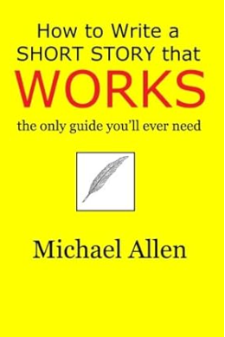
Building on the ideas of great short-story theorists from the past – Edgar Allan Poe, Professor Walter B. Pitkin, and Thomas H. Uzzell – author Michael Allen adds his own fifty years of experience as a writer and publisher to provide a proven technique for success.

