Group: HE Ready 1  A-Level English Y1 |  |  | Subject: A-Level Language and Literature | Term: 2
Teacher: |  | Molly Vellacott and Emma Ireland
Curriculum: HE Ready 1
Term 2 focus:

HT3:
Emma Ireland
Translations by Brian Friel
Molly Vellacott
Tess of the d’Urbervilles by Thomas Hardy

HT4:
Emma Ireland
Voices in Speech and Writing Anthology, Pearson
Molly Vellacott
Tess of the d’Urbervilles by Thomas Hardy

This term we will be continuing our anchor text for Paper 2, Tess of the d’Urbervilles by Thomas Hardy

Our theme for this section of the exam is Love and Loss. Our explorations will use this as a lens to examine a variety of aspects of the text and its context. We will touch upon the matter of separating the authorial and narrative points of view and consider how the author manipulates our sympathies – or otherwise – for central characters.

The Voices in Speech and Writing anthology includes examples of non-literary and digital texts from the 20th and 21st century. This component has an explicit focus on the concept of ‘voice’. We will study how spoken voices are formed and written voices created in literary, non-literary and digital texts. Students will develop an understanding of how writers and speakers shape and craft language to present an identity or persona, and look at connections between texts as well as the significance and influence of context.

1 | Apply concepts and methods from integrated linguistic and  literary study as appropriate, using associated terminology  and coherent written expression
2 | Analyse ways in which meanings are shaped in texts
3 | Demonstrate understanding of the significance and influence  of the contexts in which texts are produced and received
4 | Explore connections across texts, informed by linguistic and  literary concepts and methods
5 | Demonstrate expertise and creativity in the use of English to  communicate in different ways
6 | Ask for assistance or clarification appropriately and effectively
7 | Contribute to class discussion to assist own and others’ understanding and interpretation
8 | Independently generate original ideas and responses to stimuli
Tier Three Keywords:
Prolepsis/ analepsis | Hamartia | Context | Discourse marker | Epistolary | Structure
Narrative perspective | Narrative shift | Language levels | Prosodics | Pragmatics | Semantics

You are encouraged and expected to read widely.

As a minimum, read Moll Flanders by Daniel Defoe or The Murder of Roger Ackroyd by Agatha Christie by the end of the term and tell me what you will be reading on your own account over the holidays.
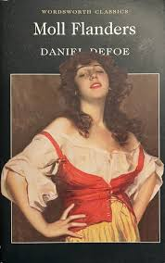
Published in 1772 Moll Flanders provides a window into women’s ways of being that do not reflect 18th century gender norms. Moll is reliant on alliances and friendships with women, many of whom fall outside of the gendered expectations of the era. One of Defoe’s notable contributions to 18th century ideas of female empowerment rests on the notion of women as agents of their own wealth. You are encouraged to consider Moll as a counter to Tess and an example of a female character depicted through a very different male gaze.

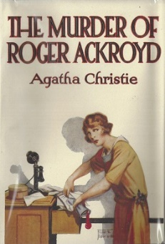

The Murder of Roger Ackroyd published in 1926 is a famous example of the “Golden Age” of detective fiction by a writer dubbed “The Queen of Crime.” Enjoy her clear and precise turn of phrase, the change of linguistic style between the different ears you have been studying, the clever plot and skilled pacing.

Recommended Reading:

