Group: M01 |  |  | Subject: English | Term: 2
Teacher: |  | Natalie Wood
Curriculum: Secondary Ready Induction
Term 2 focus:
HT1: Short Stories and Creative Writing
We will read a small selection of flash fiction texts in order to explore conventions and structure. Students will then take on the role of the writer and develop their own ideas for a flash fiction story which they will draft and publish.
HT2: 20th century play and speaking and listening
We will explore what makes effective face-to-face communication and practise how to express our thoughts, ideas and feelings in relation to the play that we will be reading – The Demon Headmaster-Gillian Cross.

Reading:
HT1: Identifying viewpoints.
HT2: Discussion of ideas, themes and contemporary issues arising from the text.
In some reading:
KO4 | I am aware of the meaning of some organisational features of texts such as bullet points.
KO5 | I notice some effective language choices. I can identify some familiar patterns.
KO6 | I know writers have viewpoints and purposes. I can say what I like and dislike, sometimes with reasons.
Writing:
HT1: Creative
HT2: Writing to support talk
In some forms of writing:
KO1 | I can choose some words for interest. My comments, questions and actions suggest what my viewpoint.
KO3 | I sometimes signal openings and closings. I sometimes put events and ideas in an appropriate order.
KO5 | I mainly use simple sentences. Some different openings. “And” connects clauses. Past, present generally consistent
KO7 | I can use straightforward, speech-like vocabulary to convey meanings. Some adventurous word choices.

Tier Three Keywords:
Narrator | Tension | Structure | Genre | Conflict | 1st person
Plot | Theme | Setting | Opening | Build-up | 3rd person
Mood | Character | Dialogue | Resolution | Conclusion | Opening

Recommended Reading:

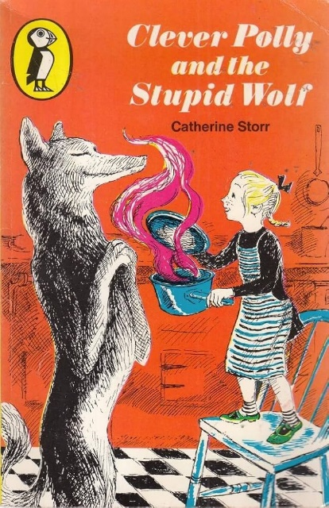
CLEVER POLLY AND THE STUPID WOLF by Catherine Storr has twelve stories written for the author's daughter, who was scared of the wolf under the bed! Drawing occasionally on well-known fairy tales, and skillfully blending fantasy and reality, these stories are bursting with humour, originality and charm. And Polly, not scared at all, outwits the wolf on each and every occasion!

There is a sequel called POLLY AND THE WOLF AGAIN, also published in the A Puffin Book series of children's modern classics

