Group: M04 and 5 |  |  | Subject: English | Term: 2
Teacher: |  | Liz Lynch Smith and Helen Hawkins
Curriculum: Secondary One Exploring
Term 2 focus:
HT1: Short Stories and Creative Writing
We will read a small selection of short stories in order to explore conventions and structure. Students will then take on the role of the writer and develop their own ideas for a short story which they will draft and publish.
HT2: 20th century play and speaking and listening
We will explore what makes effective face-to-face communication and practise how to express our thoughts, ideas and feelings in relation to the play that we will be reading.

Reading:
HT1: Structure.
HT2: Discussion of ideas, themes and contemporary issues arising from the text.
KO4 | I can comment on some structural choices and identify some organisational features.
KO5 | I can identify some language features and make comments about the writer’s choices.
KO6 | I identify main purpose, give personal response, comment on perspectives & effects of language choices.
Writing:
HT1: Creative
HT2: Writing to support talk
KO1 | I include relevant ideas with some detail. I generally establish and maintain a straightforward viewpoint.
KO3 | I organise chronologically and by clustering related. Sequencing generally logical. Some signalling.
KO5 | I can vary sentence structure & connectives. Some tense & verb form variation, generally accurate.
KO7 | I can make some deliberate vocabulary choices. I expand my vocabulary somewhat to match topic.

Tier Three Keywords:
Narrator | Tension | Structure | Genre | Conflict | 1st person
Plot | Theme | Setting | Opening | Build-up | 3rd person
Mood | Character | Dialogue | Resolution | Conclusion | Opening

Recommended Reading:

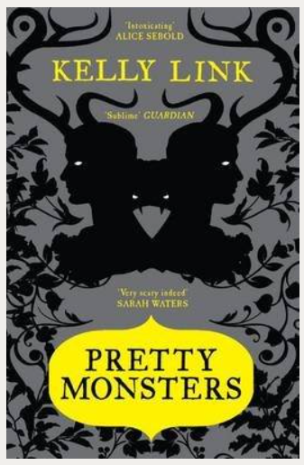
How could you possibly know that the decomposing corpse would stalk you and follow you home? And how are you going to explain it to your Mum?
The Wrong Grave is the first in this collection of short stories and sets the scene for what is to follow. With tales ranging from the macabre to the poignant and from the absurd to the mundane, many have undertones of wry humour and all are acutely observed and in some way unsettling or disturbing.
Ghosts, bloodthirsty monsters, mysterious wizards and aliens all assist with the author's metafictional manipulations, while simultaneously providing captivating entertainment.

