Group: SFD |  |  | Subject: English Lit GCSE Y2/ Y1 | Term: 2
Teacher: |  | Molly Vellacott
Curriculum: Study Programme Three
Term 2 focus:
HT1: Poetry – Relationships
HT2: Poetry - Relationships

This term we will be revisiting the GCSE Literature Specification and reading poems from the relationships cluster as well as studying a selection of unseen poetry. Teaching will have a particular focus on themes, poetic techniques, context and comparisons between the poems.

This course of study aims to enable students to read a wide range of poetry fluently and with good understanding, and make connections across them. It will help you to read in depth, critically and evaluatively, so that you are able to discuss and explain your understanding and ideas. You will be encouraged to develop the habit of reading widely and often and appreciate the range of English literary heritage.

Through practise you will be enabled to write accurately, effectively and analytically about your reading, and acquire and use a wide vocabulary, including grammatical terminology, and other literary and linguistic terms you need to criticise and analyse what you read.

As well as providing you with the knowledge to demonstrate your skills in the best light when you come to take your exams, this course will also focus on enabling us to see ourselves as connected by common feelings and responses to our experiences, by exploring the resonances in our own lives from themes explored by authors in varying contexts.

1 | Maintain a critical style and develop an informed personal response
2 | Use textual references, including quotations, to support and illustrate interpretations
3 | Analyse the language, form and structure used by a writer to create meanings and effects
4 | Use relevant subject terminology where appropriate
5 | Show understanding of the relationships between texts and the contexts in which they were written
6 | Use a range of vocabulary and sentence structures for clarity, purpose and effect
7 | With accurate spelling and punctuation
8 | Compare texts insightfully
9 | Ask for assistance or clarification appropriately and effectively
10 | Contribute to class discussion to assist own and others’ understanding and interpretation
11 | Independently generate original ideas and responses to stimuli

Tier Three Keywords:
Enjambment | Symbol | Assonance | Context | Alliteration | allegory
Imagery | Rhyme scheme | Stanza | Tone | Romantic | Meter

Recommended Reading:
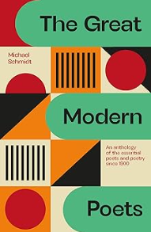

As a maturing reader you are encouraged to read widely and develop a sense of your own literary preferences whilst challenging yourself with guidance from your teacher. Extend your understanding of unseen poetry by reading The Great Modern Poets by Michael Schmidt.
This collection contains some of the greatest poems of the 20th century. Schmidt gives insights into their themes and background to their work to provide the reader with a deeper understanding and enjoyment of these poems.

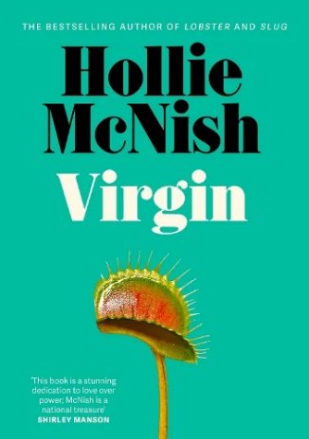

This passionate and fiercely funny new collection of poems from Hollie McNish, the author of Lobster, mines the concept of virginity, purity culture and possibilities of freedom with McNish's trademark blend of humour, fury and insight.

