Group: EW03 |  |  | Subject: English | Term: 2 | Step: 5
Teacher: |  | Angus Spencer
Curriculum: Secondary Two Exploring
Term 2 focus:
HT3 - Short Stories and Creative Writing
HT4 - Speaking and listening

Our third half term focuses on both reading and writing skills, and as a class we will be reading various short stories and extracts centring on the fantasy genre. We will connect to the teaching of HT1 from the novel as we will analyse writers’ purpose and structural choices. Throughout the half term, we will evaluate the writers’ use of language techniques and begin to implement them in our own pieces of writing. Students will then demonstrate capability in writing their own stories, using elements which they have gained from the studied texts. Students will show clear understanding through discussions and written responses and will be provided with several opportunities to showcase different sequences and structure types.

The focus for the second half term is looking at the 20th century play An Inspector Calls. As a class, we will develop understandings of dramatic conventions as we analyse characters, settings and plot. Across the course of the half-term, students will have lots of opportunities for performance and discussion.

Reading:
HT1: Structure.
HT2: Discussion of ideas, themes and contemporary issues arising from the text.

KO4 | I am aware that writers craft their writing by making structural choices. I identify and explain organisational features.
KO5 | explain and comment on writers’ use of language, including grammatical and literary features at word and sentence level
KO6 | I can identify and comment on writers’ perspectives and viewpoints, and the overall effect of the text on the reader
Writing:
HT1: Creative
HT2: Responding to play conventions

KO2 | My purpose is clear and features of the form are adapted to the purpose. My appropriate style maintains the reader’s interest.
KO3 | I structure clearly w paragraphs. I develop material. I signal direction by links between paragraphs
KO4 | I use paragraphs etc to structure writing & achieve purpose. Links between paragraphs more developed

Tier Three Keywords:
infer | identify | audience | theme | survival
evaluate | purpose | present | setting | Analyse
context | character | malevolent | hierarchy | voice

Recommended Reading:

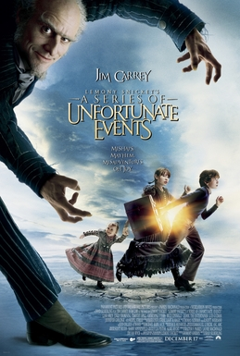

Series of Unfortunate Events by Brad Silberling

Lemony Snicket's A Series of Unfortunate Events (also known as A Series of Unfortunate Events) is a 2004 American adventure dark comedy film. Three rich orphans, Violet, Klaus and Sunny, are sent to live with their uncle Count Olaf after the tragic death of their parents. Their lives change when they learn about the evil plans of Olaf.

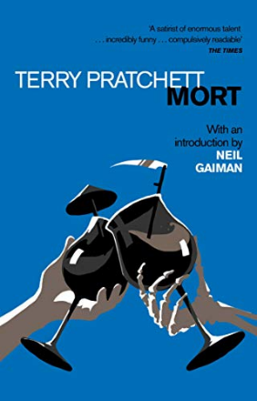

Mort by Terry Pratchett
Mort is a fantasy novel by British writer Terry Pratchett. Published in 1987, it is the fourth Discworld novel and the first to focus on the character Death, who only appeared as a side character in the previous novels.

