Group: EW05 |  |  | Subject: English | Term: 2 | Step: 5
Teacher: |  | Angus Spencer
Curriculum: Study Programme Two Deepening
Term 2 focus:
HT3 - Short Stories and Creative Writing
HT4 - Speaking and listening

Our third half term focuses on both reading and writing skills, and as a class we will be reading various short stories and extracts centring on the horror genre. We will connect to the teaching of HT1 from the novel as we will analyse writers’ purpose and structural choices. Throughout the half term, we will evaluate the writers’ use of language techniques and begin to implement them in our own pieces of writing. Students will then demonstrate capability in writing their own stories, using elements which they have gained from the studied texts. Students will show clear understanding through discussions and written responses and will be provided with several opportunities to showcase different sequences and structure types.

The focus for the second half term is to create and present a spoken presentation. Throughout the half term, the students will connect their previous teaching on discussion-based tasks and chosen specialisms into a personal presentation. Students will be able to demonstrate their presentation skills and capability to present and respond to other peers’ questions.
Reading:
HT1: Structure.
HT2: Discussion of ideas, themes and contemporary issues arising from the text.

KO4 | I am aware that writers craft their writing by making structural choices. I identify and explain organisational features.
KO5 | explain and comment on writers’ use of language, including grammatical and literary features at word and sentence level
KO6 | I can identify and comment on writers’ perspectives and viewpoints, and the overall effect of the text on the reader
Writing:
HT1: Creative
HT2: Writing to support talk

KO2 | My purpose is clear and features of the form are adapted to the purpose. My appropriate style maintains the reader’s interest.
KO3 | I structure clearly w paragraphs. I develop material. I signal direction by links between paragraphs
KO4 | I use paragraphs etc to structure writing & achieve purpose. Links between paragraphs more developed

Tier Three Keywords:
infer | identify | audience | theme | survival
evaluate | purpose | present | setting | Analyse
context | character | malevolent | hierarchy | voice

Recommended Reading:

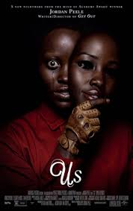

Us by Jordan Peele

Us is a 2019 American psychological horror film written and directed by Jordan Peele. Adelaide Wilson and her family are attacked by mysterious figures dressed in red. Upon closer inspection, the Wilsons realise that the intruders are exact lookalikes of them.

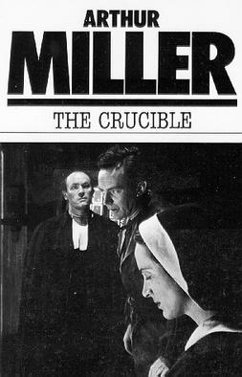

The Crucible by Arthur Miller
The Crucible is Arthur Miller's classic play about the 1692 Salem witch trials, using the mass hysteria and false accusations of witchcraft as an allegory for the 1950s McCarthyist anti-communist purges, exploring themes of guilt, reputation, mass hysteria, and the destructive power of fear and lies in a rigid theocracy.

