Group: EW08 |  |  | Subject: Arts | Term: 2
Teacher: |  | Rae Salter
Curriculum: Secondary 1 Exploring
Term 2 focus: Devising from a stimulus/ Watercolour Landscapes

Devising from a stimulus (Drama/media):
Students will explore how a range of different stimuli, including props, images, quotes and sounds, can be used to inspire a story. As a group, students will choose from a small selection of stimuli and use their chosen stimulus to inspire a short film.

Watercolour Landscapes:
Students will develop their knowledge of colour theory and the historical significance of watercolour landscape paintings. They will explore the life and works of key landscape artists, including Monet, Van Gogh, Constable and Cézanne. Students will develop their skills in design and watercolour painting by creating their own watercolour landscape.

1 | Explore a range of contrasting ideas from the same stimulus
2 | Explain creative decisions and why you made them
3 | Use a stimulus to generate devised story
4 | Share work at different stages of its progress
5 | Share final work in a chosen form
6 | Know which colours are primary (Red, Blue, Yellow) and which are secondary (Orange, Green, Purple).
7 | Know which two primary colours can be combined to make each of the secondary colours.
8 | Experiment with different methods of painting with watercolour, acrylic paint and different brush techniques examining texture.
9 | Explore and create studies of key landscape from artists such as Monet, Van Gogh, Constable and Cézanne.
10 | Draw and paint a landscape from a photo reference using watercolour paints.
Tier Three Keywords:
Stimulus | Improvise | Contrast | Colour | primary | Secondary
tertiary | Wash | Blend | Foreground | Background
Recommended Reading:
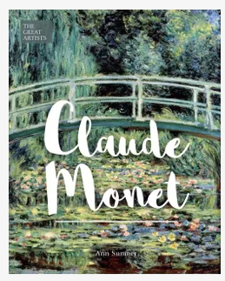
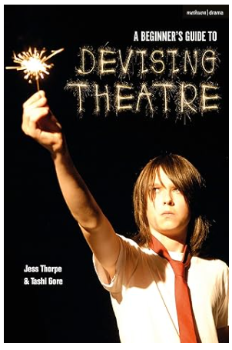
A Beginner's Guide to Devising Theatre by Jess Thorpe and Tashi Gore
Winner of the 2021 Music & Drama Education Award for Outstanding Drama Education Resource
Much of the theatre we make starts with a script and a story given to us by someone else. But what happens when we're required to start from scratch? How do we begin to make theatre using our own ideas, our own perspective, our own stories?
A Beginner’s Guide to Devising Theatre, written by the artistic directors of the award-winning young people’s performance company Junction 25 and is aimed at those new to devising or wanting to further develop their skills. It explores creative ways to create original theatre from a contemporary stimulus.
It offers a structure within which to approach the creative process, including ideas on finding a starting point, generating material, composition and design; it offers practical ideas for use in rehearsal; and it presents grounding in terminology that will support a confident and informed approach to production.
The book features contributions from some of the young performers who have been a part of Junction 25's work to date, as well as key artists and companies that work professionally in devised theatre, including case studies from Quarantine, the Team, Mammalian Diving Reflex, Nic Green and Ontroerend Goed. The work of Junction 25 is used to illustrate the concepts and ideas set out in the book.
Ideal for any student faced with the challenge of creating work from scratch, A Beginner's Guide to Devising Theatre offers constructive guidance, which supports the requirements of students taking Drama and Theatre Studies courses. The book includes a foreword by theatre critic Lyn Gardner.

Claude Monet: The Great Artists by Ann Sumner
Claude Monet (1840–1926) was one of the original Impressionist group whose subjects were modern life and the play of light on people and landscape. This richly illustrated introduction to his life and work traces Monet’s style and preoccupations from early success at the official Salon (with Camille in 1866) to his final paintings of the waterlilies in his garden at Giverny.

