Group: GCSE Y1 |  |  | Subject: Music | Term: 2
Teacher: |  | Rae
Curriculum: Secondary 2 Exploring
A0S1: Western Classical Tradition 1650-1910:
Students will develop an understanding of the western classical tradition; defined as art music of (or growing out of) the European tradition, normally notated, and normally intended for public performance. Students will be able to listen attentively to unfamiliar music from the following styles/genres to identify and accurately describe musical elements, musical contexts and musical language:
• The Coronation Anthems and Oratorios of Handel.
• The Orchestra Music of Haydn, Mozart and Beethoven.
• The piano music of Chopin and Schumann.
• The Requiem of the late Romantic period.
Students will also develop a good knowledge and understanding of the musical features of the following set work:
Beethoven: Symphony No.1, Movement 1: Adagio molto – Allegro con brio

A0S2: Popular Music
Students will explore a number of musical styles and genres including rock, pop, musical theatre, film and computer gaming music from 1950 to the present. Students will be able to listen attentively to unfamiliar music from the following styles/genres to identify and accurately describe musical elements, musical contexts and musical language:
• music of Broadway 1950s to 1990s
• rock music of 1960s and 1970s
• film and computer gaming music 1990s to present
• pop music 1990s to present.
Students will also develop a good knowledge and understanding of the musical features of the following set works:
Queen – the following three tracks:
• Bohemian Rhapsody
• The Seven Seas of Rhye
• Love of my Life

1 | Know what DR SMITH stands for and understand each musical elements (dynamics, rhythm, structure, metre/melody, instrumentation, tonality/texture/timbre/tempo, harmony).
2 | Actively listen to unfamiliar music and identify and describe its musical elements using DR SMITH.
3 | Know the musical contexts for the works of key Baroque, Classical and Romantic composers. (Handel, Haydn, Mozart, Beethoven, Chopin, Schumann)
4 | Understand key events of the 1950s to present day and the impact that these had on popular music.
5 | Use DR SMITH to describe the musical elements of musical theatre, pop, rock, film and computer game music of the 20th and 20st centuries.
6 | Develop a good knowledge and understanding of the musical features of Bohemian Rhapsody by Queen
7 | Develop a good knowledge and understanding of the musical features of The Seven Seas of Rhye by Queen
8 | Develop a good knowledge and understanding of the musical features of Love of my Life by Queen
9 | Develop a good knowledge and understanding of the musical features of Symphony No.1, Movement 1: Adagio molto – Allegro con brio by Beethoven

Tier Three Keywords:
Dynamics | Rhythm | Structure | Metre | Melody | Instrumentation
Texture | Timbre | Tonality | Tempo | Harmony | Baroque
Classical | Foley | Miasma | Exposition | Development | recapitulation
Half Term 1 Assessment
Daily Assessment | Substantive Assessment
- Active listening activities
- Class discussions
- Building a portfolio of composition ideas
- Starter recall questions

Half Term 2 Assessment
Daily Assessment | Substantive Assessment

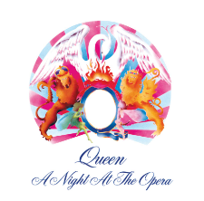
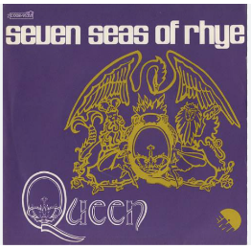
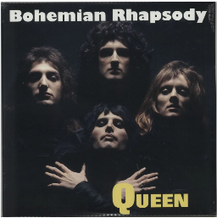
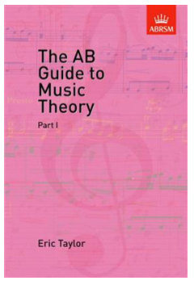
Recommended Reading (and Listening):

The AB Guide to Music Theory Part I by Eric Taylor

Provides an introduction to the basic elements in harmony and musical structure. Covers the basics of rhythm and tempo, an introduction to pitch, intervals and transposition, articulation, ornaments, and reiterations.

Bohemian Rhapsody By Queen

"Bohemian Rhapsody" is a song by the British rock band Queen, released as the lead single from their fourth studio album, A Night at the Opera (1975).

The Seven Seas of Rhye By Queen

The song Seven Seas of Rhye by Queen has a fascinating story. We were first introduced to the track as a short, rudimentary instrumental version, tucked away at the end of the group's debut album Queen (1973). Later we got a fully realised, definitive version on Queen II (1974).

Love of My Life By Queen

"Love of My Life" is a song by the British rock band Queen from their 1975 album A Night at the Opera.

Symphony No.1, Movement 1: Adagio molto – Allegro con brio by Beethoven

Ludwig van Beethoven's Symphony No. 1 in C major, Op. 21, was dedicated to Baron Gottfried van Swieten, an early patron of the composer. The piece was published in 1801 by Hoffmeister & Kühnel of Leipzig. It is not known exactly when Beethoven finished writing this work, but sketches of the finale were found to be from 1795

