Group: Y12 |  |  | Subject: Construction | Term: 2
Teacher: |  | Tom
Curriculum: (Delete as appropriate) KC Induction / Fundamentals KS3 / Exploring KS3 / Deepening KS3 / KC Exploring KS4 / Deepening KS4 / KC P18 Ready / KC Advancing KS5

Learners will revisit and further develop a detailed understanding of how walls, floors and roofs are constructed, and you will be able to name each component part, along with its functions. This will change with each different type of construction method that can be employed in a building. This is the lead up to the exam in the summer.

Term 1 focus: BTEC Unit 3 Construction and design - Internal Synoptic and completion of Unit 1, Construction Technology
1 | Revisit, reflect and revise sub-structures of low-rise buildings less than 12 metres in height
2 | Revisit and revise super-structure of low-rise buildings up to 12 metres in height – Walls including timber frame and block and brick.
3 | Revisit and revise super-structure of low-rise buildings up to 12 metres in height – roofs including pitched and flat
4 | Revisit and revise the parts of a floor
5 | Revisit and revise the parts of a wall and wall openings
6 | Revisit and revise the parts of a roof and safe construction of a roof.
7 | Revisit and revise methods of sustainability including the use of low embodied energy resources.
8 | Visit greenfield and brownfield sites and discuss the advantages and disadvantages of each.
9 | Evaluate the cost and time implications of different types of building structures.
10 | Prepare to the exam in May by completing past papers
Tier Three Keywords:
Sustainability | Short pile | Strip | Rafters | weephole | flush
Brownfield | Raft | Fascia | Wall tie | mortar | weathered
Greenfield | Trench | Soffit | Lintel | bucket | recessed
Recommended Reading:
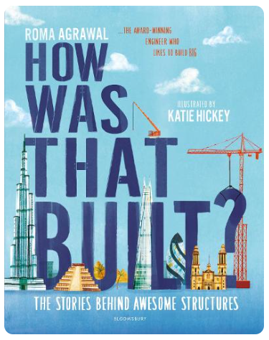The world is full of incredible structures. Skyscrapers soaring up to the clouds, bridges reaching across the widest, deepest rivers, tunnels boring deep into the earth But have you ever stopped to wonder how they were built?

