Groups: C06, C07 & C08 |  |  | Subject: Drama and Oracy | Term: 2
Teacher: |  | Lizzie
Curriculum: Deepening KS3.
Term 1 focus: Introduction to BTEC Drama
1 | Join in with activities to develop confidence and deepen understanding of performance techniques
2 | Understand and apply vocal and physical skills to create a character or presentation
3 | Demonstrate reciprocal working in a pair or group
4 | Research facts and statistics to back up opinions on a given topic
5 | Create a structured argument using logical points in a class debate
6 | Use debating techniques alongside body language as a persuasive tool
7 | Give positive and constructive feedback to support peers during the development and performance process
8 | Show understanding through answering questions and partaking in group discussions
9 | Use Role on the wall and other Drama techniques to bring a character to life
10 | Find Given Circumstances within a scripted scene

Tier Three Keywords:
Vocal | Physical | Script | Opposition | Setting | Floor
Perform | Proposition | Body Language | Given Circumstance | Character | Audience
Direct | Expression | Presentational | Intonation | Context | Debate

Recommended Reading (and watching):

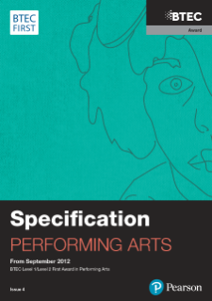 BTEC First Award in Performing Arts Specification

