Group: C08 |  | Subject:  PSHE | Term: 2
Teacher: | Joanne Pearce & Will Burton
Curriculum: Secondary 1 deepening
Term focus: Health related decisions; First Aid; Online behaviour.
Students will build their confidence in making appropriate and informed decisions regarding their own health. They will become more able to assess and manage the risk of lifestyle procedures. Students will revist and build confidence and expertise in CPR . Students will build on their existing digital literacy awareness and think about their behaviour online and how they interact with others they may or may know in real life.
1 | the purpose of blood organ and stem cell donation for individuals and society
2 | how to take increased personal responsibility for maintaining and monitoring health, including cancer prevention, screening and self- examination
3 | to assess and manage risks associated with cosmetic and aesthetic procedures including tattooing, piercings and the use of sunbeds
4 | the ways in which industries and advertising can influence health and harmful behaviours
5 | to increase confidence in performing emergency first aid and life- saving skills including CPR and the use of defibrillators
6 | to understand the potential impact of the portrayal of sex in pornography and other media, including on sexual attitudes, expectations and behaviours
7 | the impact of sharing sexual images of others without consent
8 | how to manage any requests or pressure to share any images of themselves or others and how to get help
9 | to evaluate different motivations and contexts in which sexual images are shared, and the possible legal, emotional and social consequences
10 | to understand how the way people present themselves online can have positive and negative impacts on them
11 | to make informed decisions about whether different media and digital content are appropriate to view and develop the skills to act on them

Tier Three Keywords:
Blood donation | Organ donation | Stem cell donation | Self-examination | Aesthetic | Cosmetic
Pornography | Sexting | Consequences | Motivations | CPR | Defibrillator
Anonymity | Sharing nudes | Privacy | Digital content | Platform | Authorities

Recommended Reading:

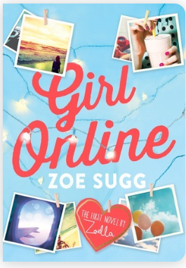
Girl Online - Zoe Sugg
Penny has a secret.
Under the alias GirlOnline, she blogs about school dramas, boys, her mad, whirlwind family - and the panic attacks she's suffered from lately. When things go from bad to worse, her family whisks her away to New York, where she meets the gorgeous, guitar-strumming Noah. Suddenly Penny is falling in love - and capturing every moment of it on her blog.
But Noah has a secret too. One that threatens to ruin Penny's cover - and her closest friendship - forever.

