Group: M01 |  |  | Subject:  PSHE | Term: 2
Teacher: |  | Natalie Wood
Curriculum: Secondary ready
Term focus: Puberty and sexual health; First Aid; Bullying and online safety.
By the end of the term, students will feel confident discussing the changes to the body brought on by puberty and will have a basic understanding of how and why contraception is used. They will have been introduced to CPR and be aware of how a defibrillator works. Students will be able to recognise signs of abuse and bullying and know how to safely challenge and seek help.

1 | Strategies to manage the physical and mental changes that are a typical part of growing up including puberty and menstrual wellbeing
2 | the communication and negotiation skills necessary for contraceptive use in healthy relationships
3 | the risks relating to unprotected sex
4 | about the purpose, importance and different forms of contraception; how and where to access contraception and advice
5 | that certain infections can be spread through sexual activity and that barrier contraceptives offer some protection against certain sexually transmitted diseases
6 | How to get help in an emergency, and perform basic first aid, including cardio-pulmonary resuscitation (CPR) and the use of defibrillators
7 | the characteristics of abusive behaviours, such as grooming, sexual harassment, sexual and emotional abuse, violence and exploitation; to recognise warning signs, including online; how to report abusive behaviour or access support for themselves or others
8 | to recognise bullying, and its impact, in all its forms; the skills and strategies to manage being targeted or witnessing others being bullied
9 | about the unacceptability of prejudice based language and behaviour, offline and online, including sexism, homophobia, biphobia, transphobia, racism, ableism and faith based prejudice
10 | the need to promote inclusion and challenge discrimination, and how to do so safely, including online.

Tier Three Keywords:
Puberty | Menstruation | Sex | Conception | Pregnancy | Contraception
Hormonal | Barrier | STI | Unprotected | CPR | Defibrillator
Abusive | Bullying | Prejudice | Discrimination | Phobia | Inclusion
Recommended Reading:

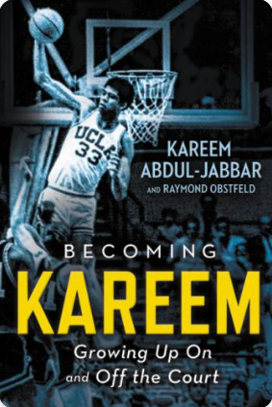
Becoming Kareem – Growing up on and off the court.

The memoir of a top sports star who has faced real adversity to get to the top of his game. Facing racism and adversity he became a champion for social justice.

