Group: M03 |  |  | Subject: Computing | Term: 2
Teacher: |  | James Elliott
Curriculum: Secondary One: Exploring Y8
Term 2 focus: The internet of things’ & Introduction to Scratch.
Firstly, our group will begin by studying into the concept the ‘The internet of things’ looking into the networks, the mechanics of the internet and its services. Secondly, we will move into gaining and developing programming skills through Scratch.

1 | I can Define what a computer network is.
2 | I can define what the internet is.
3 | Recognising network hardware.
4 | Define ‘protocol’ and provide examples of non-networking protocols.
5 | Explain how data is transmitted between computers across networks.
7 | Define ‘bandwidth’, using the appropriate units for measuring the rate at which data is  transmitted
8 | Describe key words such as ‘protocols’, ‘packets’, and ‘addressing’.
9 | Explain how data travels between computers across the internet.
10 | Explain the difference between the internet, its services, and the World Wide Web
11 | Comparing how computers and humans understand instructions.
12 | I can modify and predict an outcome from a sequence.
13 | Making sequences that include variables
14 | Define a condition as an expression that will be evaluated as either true or false
15 | I can create conditions that use comparison operators (>,<,=).
16 | Define iteration as a group of instructions that are repeatedly executed
Tier Three Keywords:
Protocol |  | Network | Hardware | Internet | Data | Transmitted
Bandwidth | Packets |  | Addressing | WWW. | Server | Router
Iteration | Sequence |  | Variables | < > | Code | Program

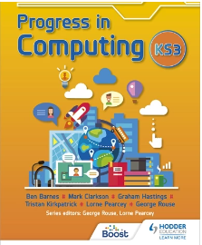
This book is designed to get you to start learning the basics in computing. It will cover all the content planned around the lessons and will provide extra support with examples of how to accomplish certain tasks in programs such as excel and PowerPoint. It will also cover networks and computer hardware/ software.
Book: ‘Progress in computing: Key stage 3’
Recommended Reading:

