Group: M04 |  |  | Subject: Computing | Term: 2
Teacher: |  | James Elliott
Curriculum: Secondary One: Deepening Y9
Term 2 focus: Kodu Game maker lab & Data Representation.
Our first topic provides students with the fundamentals of games programming using Kodu, which is a visual game development environment. Using Kodu students will understand how to build a world and program characters and objects before moving on to designing their own games. For Data representation, we will examine binary digits as the symbols computers use to perform tasks and focus on the representation of text and numbers.

1 | I can create a world and control a character using Kodu.
2 | Adding different types of paths to a world and control an enemy within a game.
3 | I can use different pages and add scoring system to a game in Kodu.
4 | I can use programming techniques in Kodu to replicate an old arcade game.
5 | I know how to use creatables to make clones of an object.
7 | I Understand the points to be considered when designing a computer game.
8 | I can create a game in Kodu from a planned design.
9 | I can recall that in data representation, representations are used to store, communicate and process information
10 | I can Explain what binary digits (bits) are, in terms of familiar symbols such as digits or letters
11 | Measuring the size or length of a sequence of bits as the number of binary digits that it contains
12 | Describe how natural numbers are represented as sequences of binary digits
13 | I can convert a denary number into binary and vice versa
Tier Three Keywords:
Programming |  | Code | Agent | Algorithm | Collision | Execute
Input | Variable |  | Loop | Condition | Bits | Binary
Sequence

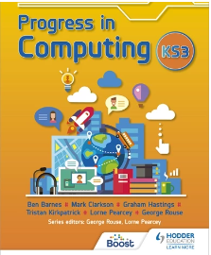
This book is designed to get you to start learning the basics in computing. It will cover all the content planned around the lessons and will provide extra support with examples of how to accomplish certain tasks in programs such as excel and PowerPoint. It will also cover networks and computer hardware/ software.
Book: ‘Progress in computing: Key stage 3’
Recommended Reading:

