Group: EW08 |  |  | Subject: Computing |  | Term: 2  05.01.26 – 27.03.26
Teacher: |  | Enike
Curriculum: Computing

Term 2 focus: The interne of things and Scratch

The internet of things:
In this unit, students explore the Internet of Things (IoT) and how everyday objects can be connected to the internet to collect, share, and respond to data. Students learn how different network components work together to create wired and wireless network access for us to use as humans. They will examine how data is gathered and used, and consider the benefits, risks, and ethical issues of connected technologies, including privacy and security. Through practical activities and discussions, students develop an understanding of how IoT systems impact modern life and how they can be designed responsibly.

Introduction to Scratch:
In this unit, students will learn how to use Scratch, a block-based programming language, to create their own interactive stories, games, and animations. They will explore how to use code blocks to control characters (sprites), add movement, sounds, and backgrounds, and respond to user input. Throughout the unit, students will develop key computational thinking skills such as sequencing, repetition (loops), and debugging, while building creativity and problem-solving skills. By the end of the unit, students will have designed and shared a Scratch project of their own.
 | Objective |  |  | Attendance |  | How do you feel about it after the lesson
1 | I can define the term internet and explain what it is |  |  | Have you been taught this content |  | G = Good  B = Bad  N = Need more support
2 | I can explain what a basic network is and identify basic network devices
3 | I understand what an IP address is and what it is used for
4 | I can identify at least two internet protocols
5 | I can define the term ‘World Wide Web’ and how we use it
6 | I know the difference between wired and wireless networks
7 | I can explain the difference between the internet and the world wide web
8 | I can explain how devices share data in the IoT and how this can impact privacy
9 | I can easily navigate through the scratch platform and understand the different areas within this coding programme
10 | I can identify objects and sprites and apply changes to them such as size, colour and rotation
11 | I can use scratch tutorials to create fun games in scratch
12 | I understand how to use sequencing and variables in scratch to enable me to improve my programming skills within scratch
13 | I can navigate through scratch and use different design choices such as frames, paint, costumes, sound, room change and more to develop a complex game within scratch

Tier Two and Tier Three words:
Router | Ethernet cable | Computer | WWW | Internet | Wi-Fi
Satellite | Switch | Protocols | IP Address | Scratch | Sprites
Objects | Code | Programming | Sequencing | Selection | Iteration
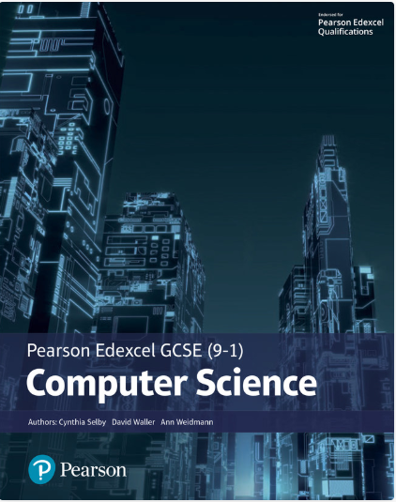The Pearson Edexcel GCSE (9-1) Computer Science 2020 student book offers:
- plenty of practical activities for programming that follow the PRIMM pedagogy
- real world examples and case studies of Computer Science in Action to help make the content relevant and inspiring to students
- worked examples and activities using the PLS or ‘Programming Language Subset’ (Python) for a simple and comprehensive approach to programming
- simplified content to make it as accessible as possible.
This Student Book also helps students concise and productive exam preparation.
Recommended Reading

Assessment

Formative | Summative
Formative assessments will be done throughout the Computing lessons.  The start of the lesson will have DNA set out for memory recall. There will be questioning during modelling, encouraging students to explain and justify their working as well as checking work.  There will also be exit tickets used at intervals during the course of study for each module | Students will be given assessments for each module that will be a summary of what they have been learning. Through these assessments students will be able to showcase their knowledge and how much they are retaining in their long-term memory  This will inform further term planning where lessons are concerned and expose any misconceptions.  For this Module students will be asked to create a PowerPoint with a specification that will showcase their skills

