Group: S2EW2 |  |  | Subject: Computing |  | Term: 2  05/01/26 – 13/03/26
Teacher: |  | Enike Musarurwa
Curriculum: S2EW2
BTEC FIRST AWARD: Information and Creative Technology

Term 2 focus: Unit 1 and Unit 3

 | Objective |  |  | Attendance |  | How do you feel about it after the lesson
1 |  |  |  | Tick if you have been taught this content? |  | G = Good  B = Bad  N = Need more support
2

3

4
5
6

Tier Two and Tier 3 Keywords:
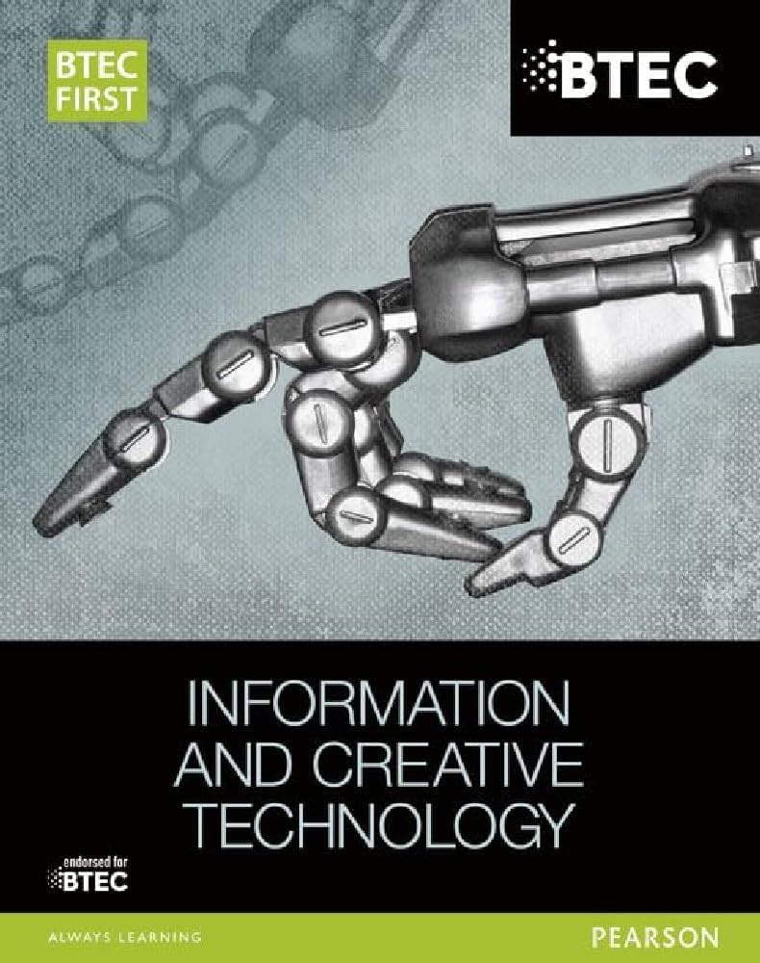 Recommended Reading:
This is the BTEC FIRST book that is related to this module and students would get a lot of useful information from this book that would prepare them for the BTEC Qualification

Assessment
Formative | Summative
Formative assessments will be done throughout the Computing lessons.  The start of the lesson will have DNA set out for memory recall. There will be questioning during modelling, encouraging students to explain and justify their working as well as checking work.  There will also be exit tickets used at intervals during the course of study for each module | Students will be given assessments for each module that will be a summary of what they have been learning. Through these assessments students will be able to showcase their knowledge and how much they are retaining in their long-term memory  Assignments will be marked internally and given back to the students to make improvements where needed  This will inform further term planning where lessons are concerned and expose any misconceptions and misunderstandings.

