Group: SFE/W1 |  |  | Subject: Computing |  | Term: 2  05/01/26 – 13/03/26
Teacher: |  | Enike Musarurwa
Curriculum: SFE/W1
BTEC FIRST AWARD: Information and Creative Technology

Term 2 focus: Unit 9 Developing Spreadsheets
Students will begin to work on a new module based on spreadsheet development.

In this unit students will understand the many uses for spreadsheets and the tools and
techniques that are available in excel, causing them to become skilled at using the application well.
Students will focus on using excel for the purposes of project management as a business. Looking at ways in which businesses use the application to improve productivity, present information, analyse data, manipulate large data sets, create tables and record results in charts and support decision making.

In addition, as part of this unit students will focus on the following learning outcomes:
- Understanding the uses of spreadsheets and the features available in spreadsheet software packages
- Design spreadsheets that are suitable for specified tasks
- Develop, test and review spreadsheets
 | Objective |  |  | Attendance |  | How do you feel about it after the lesson
1 | I can identify and explain how spreadsheets are used for different purposes |  |  | Tick if you have been taught this content? |  | G = Good  B = Bad  N = Need more support
2 | I am able to use the basic features within a spreadsheet to accomplish a specified task
3 | I am able to use Macros in an excel spreadsheet and create structure diagrams
4 | I am able to develop a spreadsheet with a realistic data set and a friendly user interface
5 | I am able to use the different functions within a spreadsheet such as “IF statements” to increase its functionality for large data sets
6 | I am able to analyse data in excel and make use of graphs and charts to present a summary of findings from different data sets.

Tier Two and Tier 3 Keywords:
Worksheets | Database | Analyse | Charts | Graphs | Cell
Functions | Excel spreadsheets | Macros | Logical Functions [IF, AND, OR, NOT] | Formula | Data set
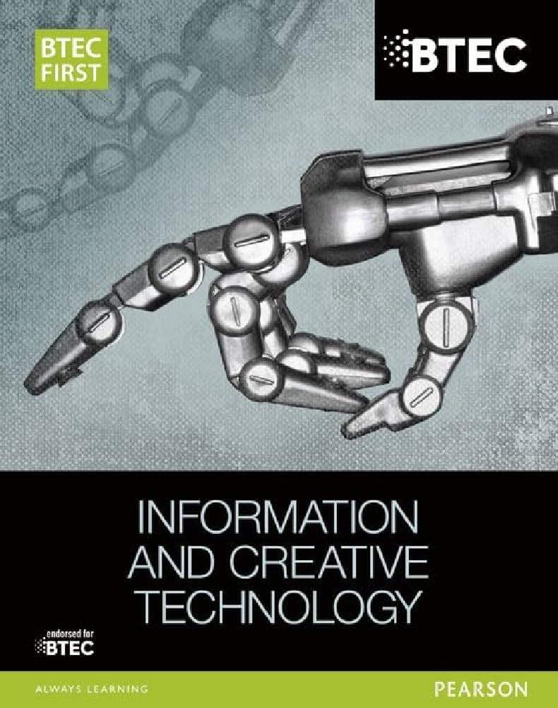 Recommended Reading:
This is the BTEC FIRST book that is related to this module and students would get a lot of useful information from this book that would prepare them for the BTEC Qualification

Assessment
Formative | Summative
Formative assessments will be done throughout the Computing lessons.  The start of the lesson will have DNA set out for memory recall. There will be questioning during modelling, encouraging students to explain and justify their working as well as checking work.  There will also be exit tickets used at intervals during the course of study for each module | Students will be given assessments for each module that will be a summary of what they have been learning. Through these assessments students will be able to showcase their knowledge and how much they are retaining in their long-term memory  Assignments will be marked internally and given back to the students to make improvements where needed  This will inform further term planning where lessons are concerned and expose any misconceptions and misunderstandings.

