Group: EWS2E |  |  | Subject: Science | Term: 2 | Attended | RAG rating  
Teacher: |  | Ruth Coulson
Curriculum: S2 Exploring
Term 2 focus: Energy
1 | To be able to describe the different energy stores and describe transfers of energy between the different stores.
2 | To describe what is meant by conservation of energy and why it is an important idea.
3 | To understand the term ’work’ in science and be able to calculate the work done by a force.
4 | To be able to describe gravitational potential energy stores in an object as it moves up and down and be able to calculate GPE.
5 | To describe what the amount kinetic energy in a KE store depends on and be able to calculate the KE stored. Be able to calculate the amount of energy in an elastic potential store.
6 | To describe what is meant by useful and wasted energy and describe what happens to wasted energy.
7 | Explain what is meant by efficiency and be able to calculate it. Describe how machines waste energy.
8 | To understand how energy is supplied to your home and why electrical appliances are useful in transferring energy.
9 | To explain what is meant by power and how to calculate the power of an appliance.
10 | To know a range of energy resources that are used to meet the demands for energy in society. To understand how nuclear fuels are used in power stations.
11 | Summarise the different types of energy sources and evaluate the advantages and disadvantages of each type.
12 | To understand how fossil fuels and nuclear power affect the environment.
13 | To evaluate how best to use electricity supplies to meet variations in demand and be able to compare the economic costs of different energy resources.  Evaluate which energy resources need to be developed to meet people’s future energy needs.

Tier Three Keywords:
chemical | kinetic | gravitational | elastic | thermal
conservation | stores | work | friction | joules
dissipated | efficiency | power | nuclear | biofuel
renewable | Non-renewable | tidal | geothermal | fossil fuels

Recommended Reading:

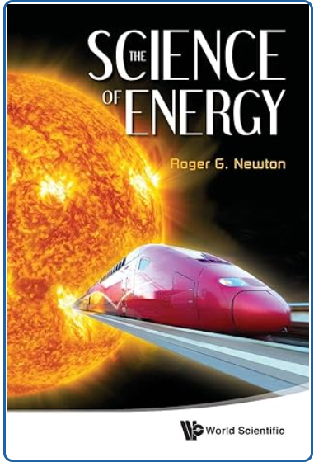

This book aims to describe the scientific concepts of energy. It starts with the basic notion of energy and the fundamental laws that govern it, such as conservation, and explains the various forms of energy, such as electrical, chemical, and nuclear. It then proceeds to describe ways in which energy is stored for very long times in the various fossil fuels (petroleum, gas, coal) as well as for short times (flywheels, pumped storage, batteries, fuel cells, liquid hydrogen).

Finally, the history of the forms of energy in the course of development of the universe is described, and how this form changed from pure radiation in the aftermath of the Big Bang to the creation of all the chemical elements in the world.

